**PPNO List Serv Query Summary**

# Infantino Julia Markham Stouffville jinfantino@msh.on.ca

Last Name First Name Institution Info email

Contact for further information:

Date of Summary:

We are looking at our staff certification courses and I am interested in knowing if other hospitals (for mandatory certifications) are currently charging a fee for staff. And if so, is it a reduced fee? Also, interested in knowing if the fee is the same for all professions or do you charge a different fee for physicians/ midwives.

Abbreviated Question (as it will appear on search results page)

Policy/Procedure  Practice  Program Info  Committee Structure info  Role  Students

Model/Structure  Care Delivery  Collaboration  Regulation/Legislation  Pt. Safety

Quality/Outcome/Indicator  PP Culture/Leadership  Other:

|  |  |  |  |  |
| --- | --- | --- | --- | --- |
| Name of hospital | Courses offered on site | Fee Charged or Free ? | Amount charged | Same fee for all Professions? |
| RVH | BLS  NRP  ACLS  PALS  PEARS  FHSL  Other  - | Fee  Fee  Fee  Fee  Fee  Fee | $50  $150  $400 or Recert $300  $400 or recert $200  $400 or recert $200  Not known | Outside affiliates +20  Students $250 |

Health Sciences North (HSN).

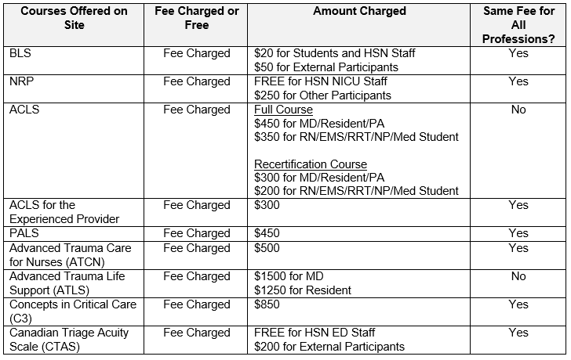

|  |  |  |  |  |
| --- | --- | --- | --- | --- |
| Name of hospital | Courses offered on site | Fee Charged or Free ? | Amount charged | Same fee for all Professions? |
| Sunnybrook | BLS  NRP  ACLS  PALS  PEARS  FHSL  Other  - | Only supported if mandatory for role (i.e nurses, RTs, OTs/PTs at st john’s site but not at bayview)  Charge if not mandatory.  Only supported if mandatory for role. Not offered if not mandatory.  Varies by program   * Mandatory (CV-ICU, CICU, Cath lab, emerge) * Recommended (CrCU) * Not required   Recommended in emerge | $40.00 (if not mandatory for role)  $0  $365 (resident, RN, PA, Paramedic)  $555 (MD, Dentist)  $80 manual /book  $400 Resident/RN/PA/Paramedic  $585 MD/Dentist  $80 Manual | Yes – for all health professions.  Supported for RNs/RTs. Physician’s are separate through medical education (?).  <https://sunnybrook.ca/education/content/?page=acls-course-toronto>  <https://sunnybrook.ca/education/content/?page=pals-course-toronto> |

|  |  |  |  |  |
| --- | --- | --- | --- | --- |
| Name of hospital | Courses offered on site | Fee Charged or Free ? | Amount charged | Same fee for all Professions? |
| Grey Bruce Health Services  Owen Sound | BLS  NRP  ACLS  PALS  PEARS  FHSL  Other  - | **BLS** – free  **NRP** – free  **ACLS** – charge  **PALS** – charge  **Non-Violent Crisis Intervention (CPI)** - free  We do not offer:  PEARS or FHSL | ACLS and PALS: Our staff are responsible for registering and paying the course provider directly. We host the course at the hospital and track completion, however, we do not manage payment. We lend out the H&S study guides for all these courses.  ACLS is roughly $425 for the full course and $350 for the Recertification.  Initial PALS is $450 and the Recertification is $250. | Same fee for all professions. |

SickKids

We offer BLS free to all our staff, there is no cost to them. External participants we charge a fee of $70 I believe.

Heartsaver BLS for internal staff = $50

Heartsaver BLS for external = $70  
  
As for PALS full certification for internal staff = $350

PALS full certification for external = $419

PALS Renewal for internal staff = $230

PALS Renewal for external = $269

We don’t provide NRP or ACLS at this time.

St. Mikes

Our costs are advertised as:

Recert – $275 for RN and $375 for MD

Full cert - $350 for RN and $475 MD

We currently do not host PALS or NRP through the centre.

*Imbedding Attachments: When in a document, with the cursor in the place where you wish to insert another document as an icon, Go to Insert, choose "Object" (not 'file') choose "Create from File" browse for the file name from your directory, once found, check off "Display as Icon" select "OK” The document Icon now appears in this document where your cursor was positioned. Save the document you are working in and the imbedded icon with the document they relate to attached will also be saved to this document.