Lumbar Puncture
Nursing Quick Tips
Indications for LP | An LP is performed to obtain a cerebrospinal fluid (CSF) sample (i.e; suspected meningitis), measure CSF pressure, drain CSF, or access the subarachnoid space for infusion of medications or contrast agents.
Samples | 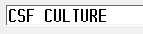    Order in EDM: &    The CSF Profile includes:  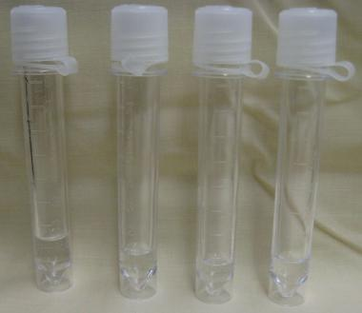  - 4 collection tubes come in the LP kit (they will be numbered 1 through 4).  - Transport fluid to lab immediately after collection (do not place in the pneumatic tube).  - (SMMH, CPH, SCH) transport to referral site at room temperature within one hour of collection.  - Stratford General Hospital lab is to be notified by telephone of the arrival of a CSF. Contact the Core Lab (ext. 2877) directly.
Equipment | 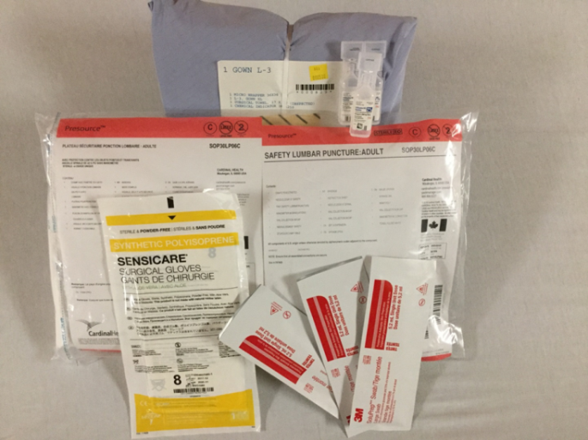  PPE (gloves, gown, cap, mask, eye protection or face shield)  +  Supplies  SEE REVERSE
Nursing Roles | 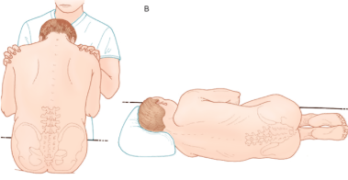  - Gather supplies.  - Place the patient in the lateral decubitus position near the side of the bed (knees to chest) or sitting position.  - Ensure that the head of the bed is flat and that there is no more than one small pillow under their head.  - Provide emotional support and reorientation as required.  Sitting or Side Lying  Photo source: accessemergencymedicine.mhmedical.com  - The physician may pass you the CSF samples as they are collected. Ensure that each tube is labeled in the order in which the specimens were collected. The tubes will be numbered 1 through 4 and your lab labels will also be numbered.
Monitoring | - Monitor the patient’s neurologic, respiratory, and cardiovascular status during the procedure.  - Observe the patient for changes in level of consciousness, headache, pupil size and reactivity, motor or sensory function, and vital signs.  - The patient should remain in a position of comfort post procedure.  - Assess the puncture site for CSF leakage or bleeding. Change the dressing as needed.

References and additional resources:
Elsevier Module: Lumbar Puncture.
InterHospital Laboratory Partnership, Specimen Collection Manual. (2013). Body Fluid-Cerebrospinal Fluid. Retrieved from http://172.16.0.13/dsweb/Get/Document-9683/Body%20Fluid_CSF.pdf

