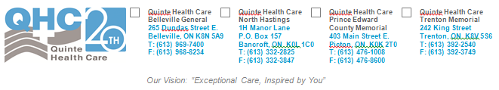

# Student Pre-Placement COVID-19 Checklist

School/Organization Name:

School/Organization Representative:   
Phone: ______ Email: ________

# Instructions for completion

By signing this document the School/Organization Representative confirms that the following criteria are met for each student coming to Quinte Health Care for placement:

|  |  |  |  |
| --- | --- | --- | --- |
|  | Yes | No | N/A |
| Student has completed a P100 mask fit test through our Safety Office. If not completed, an apt. is booked. To book with us, please have the student email [admin@walshandassociates.ca](mailto:admin@walshandassociates.ca)  to make an apt. There is a $40 charge for this service.  ***The P100 mask is NOT required for all students, please confirm with Kristen Stewart if it is required for your students.  ***Please do not have students email to book until roughly 2 weeks before placement start date. |  |  |  |
| Student has received and reviewed the Quinte Health Care PPE overview, and signed off |  |  |  |
| Student has received and reviewed the video on limited reuse |  |  |  |
| Student has received access/orientation to the screening app (instructions to be given separately) |  |  |  |
| If student is coming from outside of our ‘safe zone’ which includes: Hastings & Prince Edward, Kingston, Frontenac & L&A, Peterborough, Renfrew, Haliburton/Kawartha/Pine Ridge, they have self-isolated for the required 14 days prior to starting placement. |  |  |  |
| If you answered "no" or "NA" to any of the above, please explain: |  |  |  |

School/Organization Representative Signature: Date