SCOPE:

This policy and procedure applies to employees of the Royal Victoria Regional Health Centre (RVH), as well as residents and high school, college and university students placed at RVH, referred to collectively as students herein. While volunteers and professional staff (i.e., medical, dental, midwifery, and extended class nurses) are not RVH employees, they are vulnerable to many of the same workplace hazards, including workplace violence, and are therefore included in this policy and procedure.

Where procedural differences in reporting or investigation exist, they shall be highlighted where applicable. Otherwise, the collective term workers shall be used to refer to all of the groups indicated above. The requirements apply whether working on RVH property or working on behalf of or representing RVH elsewhere.

POLICY STATEMENT:

At the Royal Victoria Regional Health Centre, Safety is Our Promise. RVH recognizes the potential for violence in the workplace and is committed to taking every precaution reasonable in the circumstances to identify then minimize or eliminate potential sources of this risk.

Violence in the workplace can have devastating effects on workers’ quality of life and organizational productivity. In order to directly and effectively address this issue, the Ontario Occupational Health and Safety Act (OHSA) was amended in 2010 to include specific requirements with regard to the control and prevention of workplace violence and harassment. Please refer to Corporate Administrative Policy and Procedure (2018) Workplace Harassment Prevention, for further information on the prevention of workplace harassment, including workplace sexual harassment.

This policy provides a framework for consistent identification, reporting, response, documentation, investigation, control, follow-up, and education regarding all acts of, attempted acts of and threats of violence in the workplace. It further provides information for the four categories of workplace violence: External, Client/Customer, Worker to Worker, and Domestic Violence (see Definitions, below).

DEFINITIONS:

Alarm (Portable/Mobile): A device used to summon immediate assistance, whether from colleagues in the immediate vicinity or from Security Services. Where deemed mandatory (in accordance with the Workplace Violence Risk Assessment for each unit or department), it shall be personally issued to workers and its use shall be a condition of employment in that area. Where not deemed mandatory, it may be signed out electively by workers. The following alarm devices are available at RVH:

- Personal panic alarm (portable Code White button): A device that, when activated (by pushing and holding for 4 to 6 seconds) transmits a signal to notify Locating to initiate a Code White and to have Security Services respond to the area. Once pushed, an audible overhead enunciator (steady sound within that department ONLY) and/or overhead Code White page (throughout the building) will be heard within 10 seconds.

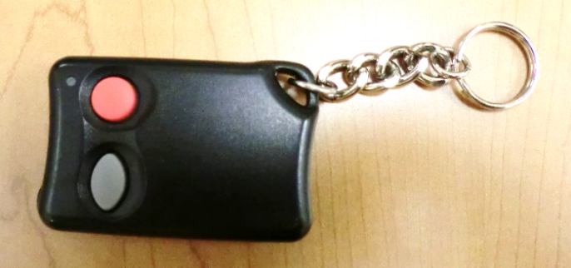 | 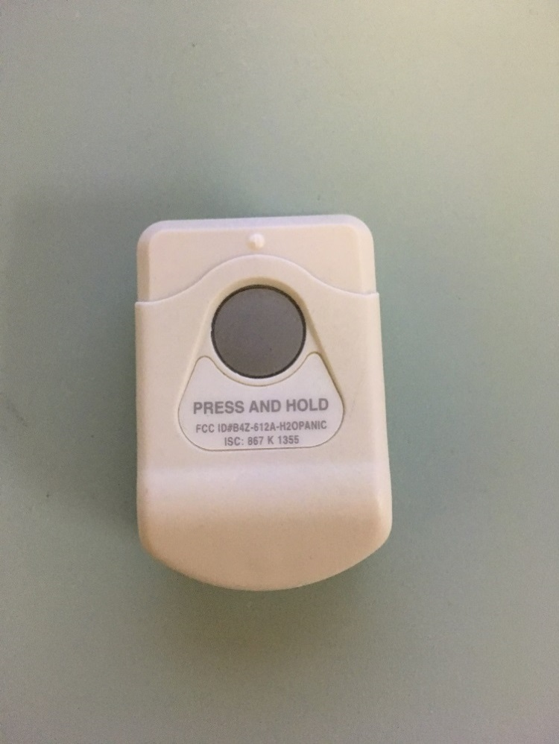
ACTIVATION BUTTON (press and hold for 4-6 seconds)
If nothing is heard overhead after 10 seconds, the user shall immediately dial 55 to Locating to initiate a Code White. If a phone is not readily accessible, the user shall pull the Staff Alert Pendant to gain the immediate attention of colleagues in the department – colleagues shall dial 55 then run to provide assistance.

This device shall be worn high on the body or in such a way as to prevent accidental activation (e.g., depressed while sitting or leaning against objects). Note that personal panic alarms are NOT interchangeable from department to department – they function ONLY within the department in which they were issued (by transmitter frequency).

Where stipulated by the department leader (and documented in its Workplace Violence Risk Assessment):
- Mandatory (for employees and students only) to be worn for the duration of each shift in the designated department
- Mandatory to be tested on a monthly basis by the worker to whom it is issued (to be performed and documented as required in the designated department – the worker shall first notify Locating of testing to prevent a false Code White)

Benefits: Automatically transmits a signal to Locating, initiating a Code White to Security Services
Limitations: Requires 4 to 6 seconds of steady depression to be activated, does not sound an audible alarm at the point of use, does not locate/identify the worker who has activated it

- Staff alert pendant: A device that, when activated (by pulling its pin), produces a constant 120dB sound. This device does NOT transmit a signal of any kind. An immediate call of 55 to Locating shall be placed when this sound is heard in order to obtain Security assistance or to initiate a Code White. Workers in the vicinity hearing this sound shall immediately attend and provide assistance until Security Services arrive. This device shall be well secured in the upper left quadrant of the chest (NOT to be attached to the retractable portion of a lanyard).  - Mandatory (for employees and students at this time – highly recommended but elective for other types of workers). Note the |  | 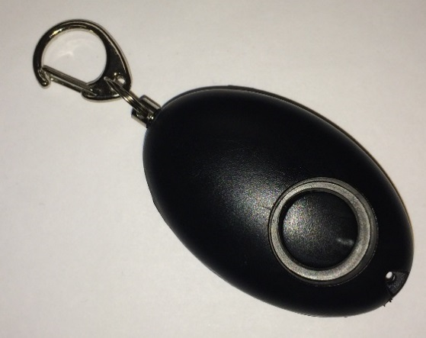  PIN SOUND SOURCE (speaker)  (pull to activate, push in to stop)
exception of Security Services and Facilities and Building Operations workers who carry portable radios. The radio’s man-down button shall be depressed when immediate assistance is needed.
- Mandatory (as noted above) to be worn for the duration of each shift
- Mandatory to be tested ahead of each shift by the worker to whom it is issued (to be performed by muffling the speaker then pulling the pin in a quiet, unoccupied area to prevent a false Code White)

Benefits: Automatically draws attention to the worker who has activated it, may startle the aggressor to halt the violence, does not need to be depressed for several seconds to activate – activates immediately when pulled
Limitations: Does not transmit a signal to activate a Code White – the second step of calling 55 or depressing a fixed/portable Code White button is required

- Connecting Care SMART badge: A device that, when activated (by pushing the Duress button), locates the worker to within 1 foot, visible on the Connecting Care monitor at the nursing station and patient rooms. The device transmits a signal to initiate a Code White, causing an overhead announcement to occur. A follow-up call of 55 to Locating is required to communicate pertinent information to Security. This device does not make any sounds when the Duress button is pushed. The Staff Alert Pendant shall be pulled to sound an audible signal, as needed. This device shall be worn in the upper left quadrant of the chest.  Mandatory (for employees only at this time, on a department-by-department basis as rolled out): The SMART badges are being rolled out throughout the organization in a phased approach. At the time of this writing, the receivers are not being installed in off-site facilities, including the Rotary building. Until they have been provided to all workers, Staff Alert Pendants shall remain mandatory as noted above. | 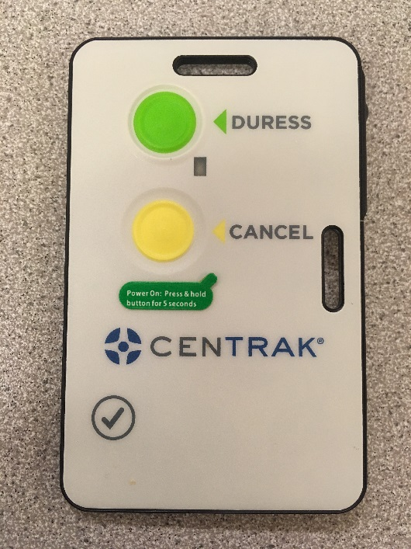  Duress button
- Mandatory (as noted above) to be worn for the duration of each shift
- Mandatory to be tested as instructed by Interprofessional Practice

Benefits: Locates the worker to within a very precise location, automatically transmits a signal to initiate a Code White
Limitations: Does not sound an audible alarm at the point of use

Button (Fixed/Stationary): A permanently mounted or affixed mechanism that, when pressed, transmits a signal to Locating to initiate a Code White from Security Services. The following buttons are installed in RVH facilities:

- Code White (fixed) button: A button that, when activated, transmits a signal to Locating to initiate a Code White to Security Services. This button does NOT produce an audible alarm. These are typically installed in open inpatient areas (e.g., patient gyms, patient recreation rooms, patient meal rooms, etc.), in open outpatient areas (e.g., registration desks, adjacent to waiting rooms, cashier’s office, etc.) or publicly-accessible worker areas (e.g., Rotary Tunnel, Human Resources, Administration, Wellness Centre, etc.). Testing is facilitated by Security Services. There are different types of fixed Code White buttons, depending on the location. See examples below:
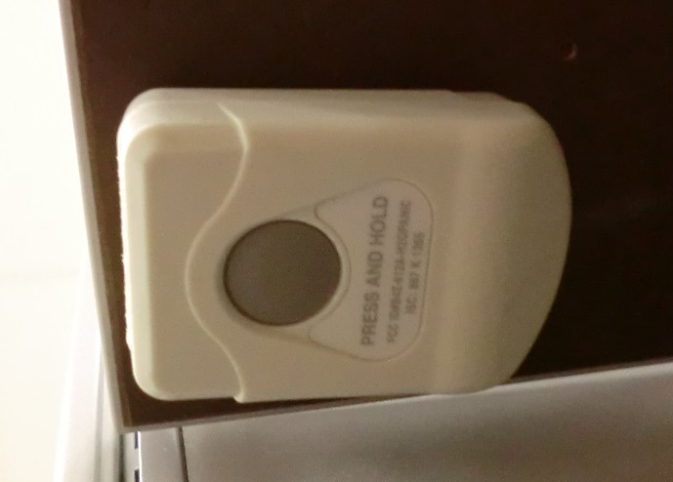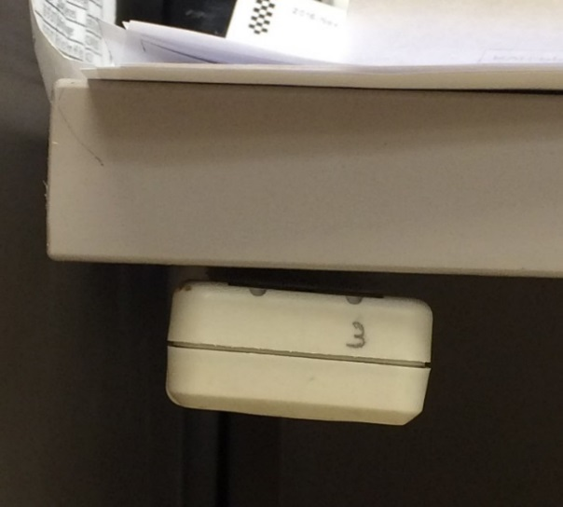
Example in Main Pharmacy, mounted on the underside of a desk (views from below and from side).

This type is NOT hard-wired. They are typically attached by Velcro or some other removable/non-permanent means. They are activated by pushing and holding the button for 4 to 6 seconds. Note that they cannot be removed for use in another department – they function only within the department in which they’ve been placed (by transmitter frequency).
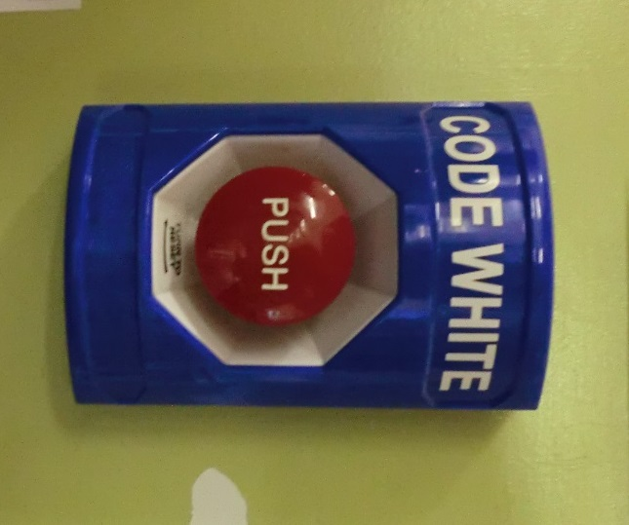 | Example in Emergency Major (Trauma), mounted on the wall at the Nursing Station.  This type is hard-wired. They are permanently fixed to a wall (not removable). They are activated by pushing and releasing the button.
- Staff assist (fixed button): A button that, when activated, sounds an audible alarm at that unit’s nursing station only. This button does NOT transmit a signal outside of that unit. These are typically installed in patient care areas (e.g., patient rooms on the head board, patient washrooms, patient showers, etc.). Testing is facilitated by Security Services. There are several types of Staff Assist buttons, depending on the location. Also, some have covers over them (to prevent false Code Blue calls) while others don’t. All are activated by pushing and releasing. See examples below.

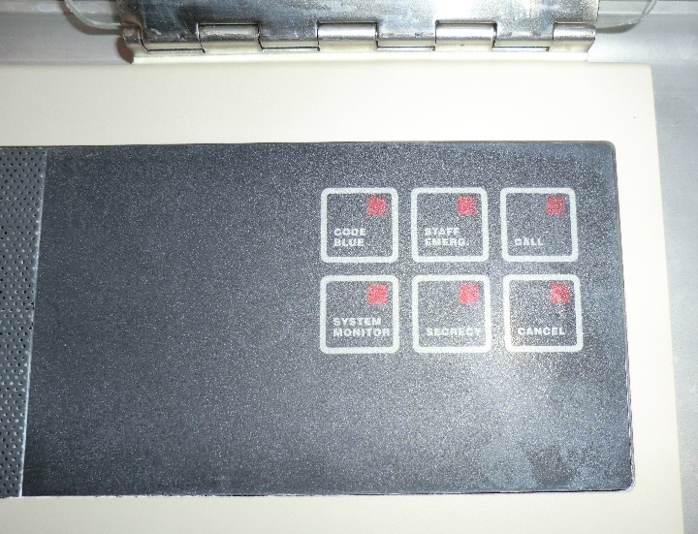  Example in Intensive Care Unit with plastic cover lifted up, high on head wall |  | 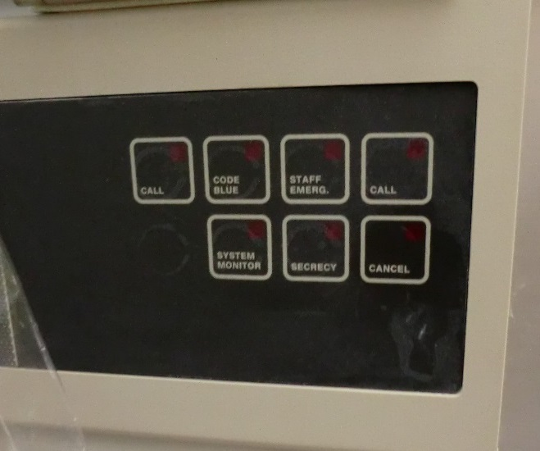  Example in Integrated Stroke Unit, no cover, low on head wall
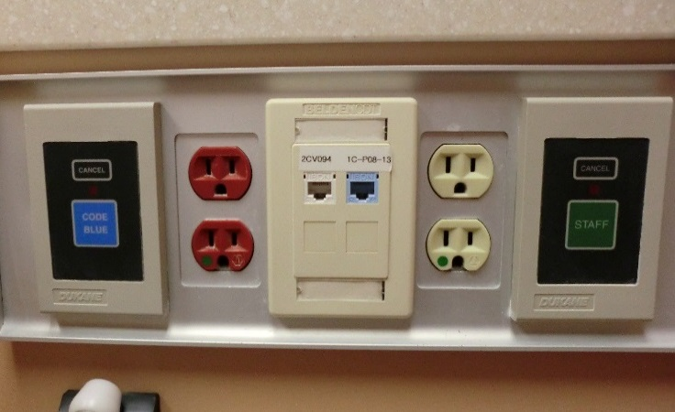  Example in Specialized Seniors’ Care Unit, no cover, middle of head wall |  |  | 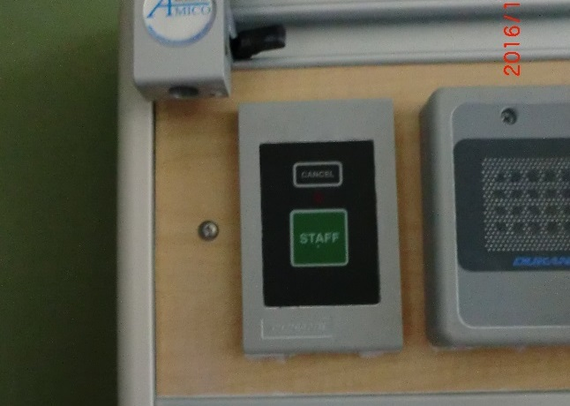  Example in Respiratory Inpatient Unit, no cover, far left of head wall

Care plan: A patient-specific inter-professional record of patient needs and wishes followed by detailed plans and interventions that follow best practices. In the context of this policy, it refers to patient-specific precautions to be followed by clinical workers while providing care to patients with a known history of violence to ensure the safety of the patients and the workers involved.
For example, two workers shall provide peri-care together, Security Services shall be called prior to administering medication, male workers shall not enter to prevent a behavioural trigger, etc.

Code white: An RVH Emergency Plan activated to summon Security Services to attend an area when immediate Security assistance is required to deal with an emergency situation of a physically, verbally or sexually violent nature (whether proactively or reactively).

Critical injury: In the context of worker safety, it is an injury of a serious nature that places life in jeopardy, produces unconsciousness, results in substantial loss of blood, involves the fracture of a leg or arm (not finger or toe), involves the amputation of a leg, arm, hand or foot (not finger or toe), consists of burns to a major portion of the body, or causes the loss of sight in an eye (OHSA). Please refer to Corporate Administrative Policy and Procedure Critical Injury and Fatality Reporting and Investigation (Workers) for additional requirements.
Not to be confused with the patient safety term critical incident (refer to Corporate Clinical Policy and Procedure Critical Patient Safety Incident Reporting and Investigation for further information).

Fatality: The loss of life.

Patient watch/observation: A one-to-one observation of a patient when that patient is at risk of self-harming and/or of harming others. For example, patients at risk of falling, suicide, elopement, pulling intravenous lines, not eating or taking medications properly, or with a known history of violence. Please refer to Corporate Clinical Policy and Procedure, Enhanced Levels of Observation for Patients for further information.

Safety plan: A documented series of safety measures created and implemented by Security Services to protect a worker’s or workers’ safety when a threat (of some form of workplace violence) has been identified via Security’s completion of a written or verbal assessment of that threat. Created in cooperation with the threatened worker(s).

SBARD: Used for internal transfers, the Situation-Background-Assessment-Recommendation-Documentation (SBARD) is a communication methodology determined to be best practice when communicating significant patient findings with the interprofessional team.

Security watch: A one-to-one observation of a patient when that patient has been identified as presenting violent and/or aggressive behaviours of an acuity that requires the training and expertise of Security Services (within the continuum of levels of patient watch, as defined above).

Violence identifier: A visual means of identifying a potentially aggressive or known aggressive patient. The identifier is placed on the outside of the patient’s room (inpatient settings only) in order to discretely warn all workers entering the room to do so with vigilance. It is not intended to stigmatize patients or alter the manner or quality of the care provided. It serves strictly to ensure that care is provided in the safest way possible for both patients and workers. | 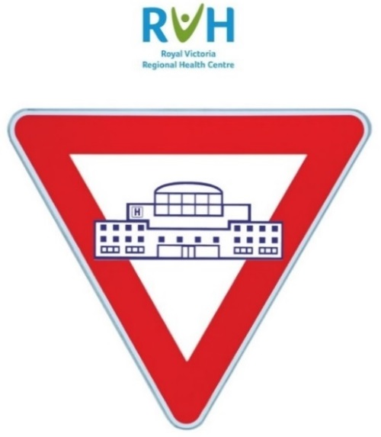
VIP: A standard notation used in Meditech to identify a Very Important Person. While it has other uses, for the purpose of this application, it serves to identify those patients known to be violent and/or requiring an immediate notification to Security Services of their presence.

Where you will see it | What it looks like
At reception or registration when the nurse or clerk enters the health card number, this message pops up  May read VIOLENT PATIENT and/or CALL SECURITY | 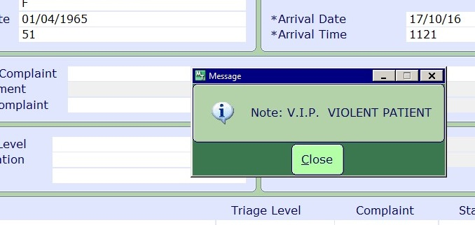
Notation entered in the registration system by Security Services only | 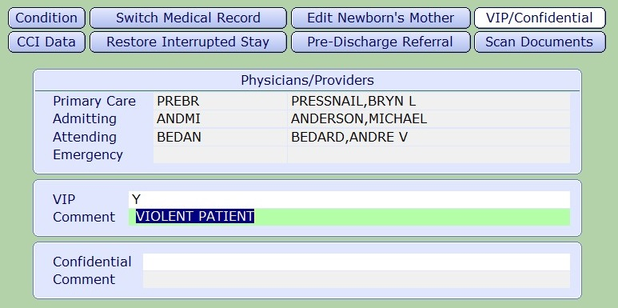
In the patient’s EMR, seen by care providers (anyone accessing the EMR) | 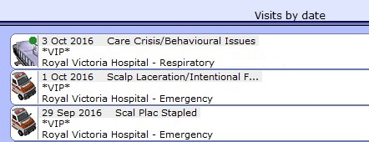

Workplace harassment: Engaging in a course of vexatious comment or conduct against a worker in a workplace that is known or ought reasonably to be known to be unwelcome, or workplace sexual harassment. Please refer to Corporate Administrative Policy and Procedure Workplace Harassment Prevention for further information.

Workplace violence:
- The exercise of physical force by a person against a worker, in a workplace, that causes or could cause physical injury to the worker,
- an attempt to exercise physical force against a worker, in a workplace, that could cause physical injury to the worker,
- a statement or behaviour that it is reasonable for a worker to interpret as a threat to exercise physical force against the worker, in a workplace, that could cause physical injury to the worker.

Examples include:
- verbally threatening to attack a worker
- leaving threatening notes at or sending threatening e-mails to a workplace or worker
- shaking a fist in a worker’s face
- wielding a weapon at work
- hitting or trying to hit a worker
- throwing an object at a worker
- sexual violence against a worker

There are four types of workplace violence:
- Client/customer violence involves a person receiving care or services (i.e., a patient) from an RVH worker, whether on RVH property or elsewhere (for example, in a patient home or off-site office). This includes violence or harassment:
  - against a worker by a patient,
  - against a patient by a worker, or
  - against a patient by a patient.
Note: “Patient” may also include the patient’s family member/visitor or other member of the public having a relationship with the workplace. The patient does not need to have the capacity to appreciate that his/her/their actions could cause physical harm in order for those actions to meet the definition of workplace violence. That is, the actions do not need to be willful or intentional. This is the most prevalent type of violence in health and community care.
- Domestic violence (also known as personal relationship violence) involves a pattern of behaviour used by one person to gain power and control over another with whom he/she/they have or have had a personal relationship (i.e., current or former spouse, intimate partner, relative, or friend). Examples include physical violence, sexual, emotional and psychological intimidation, verbal abuse, stalking, and use of electronic devices to harass and control. When an act of, attempted act of or threat of domestic violence occurs at the workplace, it becomes workplace violence, affecting the safety of the worker and his/her/their co-workers, patients and visitors.
- External violence involves a person with no relationship to the workplace who commits a violent act. Examples include theft of money, cars, drugs, and personal belongings, and acts of vandalism, hostage taking, kidnapping, and assaults by a person with no relationship to the workplace.
- Worker to worker violence involves anyone who has a current or past employment relationship (i.e., employees, leaders, professional staff, students, contract workers, and though they don’t have a true employment relationship with RVH, volunteers). Examples include acts, threats or attempts of physical, verbal or sexual assault:
  - from a worker to another worker,
  - from a worker to a volunteer or student, and vice versa,
  - from a leader to a worker, and vice versa,
  - from a member of the professional staff to a worker, and vice versa, etc.

PROCEDURE:

In the case of an act of workplace violence that results in a critical injury or fatality (see Definitions), refer immediately to Corporate Administrative Policy and Procedure Workplace Critical Injury and Fatality Management, and follow the procedures therein.

Otherwise, this procedure provides for the reporting, investigation and response to acts of, attempted acts of and threats of workplace violence as well as what to do when someone with a known history of violence enters the building (or is admitted). Security Services and Occupational Health and Safety (OHS) may advise or assist at all stages of the procedure. Where required and/or requested to do so, members of the Joint Health and Safety Committee (JHSC) and/or the Workplace Violence and Harassment Prevention Committee (WVHPC) may also participate in this process.

Please note that the procedure below does not preclude workers from exercising their right to refuse unsafe work, as defined by the OHSA Sect. 43(3)(b.1), taking into consideration OHSA Sect. 43(1) and (2). Reprisals against workers exercising this right are prohibited. Note, however, that there is a limited right to refuse work when the worker’s refusal to work would directly endanger the life, health or safety of another person, as it applies to hospital workers (OHSA Sect. 43(1)(b)). Please refer to Corporate Administrative Policy and Procedure Work Refusal and Work Stoppage for further information.

Lastly, this policy expressly prohibits reprisals against individuals acting in good faith who report acts, attempted acts of or threats of workplace violence or act as witnesses thereof. Leaders shall take all reasonable measures to prevent reprisals, threats of reprisal or further violence. Reprisal is any act of direct, indirect, threatened, or implied retaliation.

Arrival/Admission of Patient/Person with Previous History of Violence

Patients and other people may enter or be admitted to RVH with a known history of violence in other facilities and/or from past visits to RVH though are not exhibiting such behaviour during their current visit. The requirement to ensure the provision of high quality patient care shall be balanced with the requirement to ensure worker safety.

In accordance with the Occupational Health and Safety Act (OHSA), workers within the circle of care shall be advised of the existence of any potential or actual danger to health or safety and shall be provided information, including personal information, related to a risk of workplace violence from a person with a history of violence behaviour if the worker can be expected to encounter that person in the course of his/her/their work (i.e., is within the circle of care, likely to interact directly with that person) AND the risk of workplace violence is likely to expose the worker to physical injury. However, only the pertinent personal information that is reasonably necessary to protect the worker from physical injury shall be disclosed (OHSA Sect. 32.0.5(4)).

As such, when a patient is admitted from another facility having a known history of violence in that facility or when a patient (or person known to typically accompany that patient) enters RVH having a known past history of violence at RVH, that history shall be communicated to any RVH workers expected to provide care for or otherwise closely interact with that person, even if no such behaviour is being exhibited at the time of the current admission or entry.

This history may be verified by means of:
- VIP notation in Meditech, with a corresponding comment of PT V and/or warning to notify Security Services immediately (noted upon registration of the patient and access to the patient’s chart)
- Direct questioning by the admitting or receiving RVH worker to the transportation or facility representative when the patient arrives directly from another facility and there are reasonable grounds to expect a history of violence in that facility

Once admitted to or identified to be inside RVH, further communication of that history shall be by any or all of the following means, as appropriate in the circumstances:
- Assessment by the care provider(s) and/or Security Services (against criteria provided in Appendix I: Criteria for Placing a Violence Identifier) and, if deemed necessary, flagging of the patient with a Violence Identifier posted outside the patient’s room (in all inpatient units other than Mental Health Inpatient).
  - Inpatient units have been provided with their own violence identifiers. The patient’s care provider(s) shall post an identifier based on evaluation of set criteria that identify the potential risk of workplace violence (refer to Appendix I: Criteria for Placing a Violence Identifier). Communication of the patient’s status shall further be provided care provider-to-care provider, via SBARD.
  - If flagging of the patient as VIP is required (an alert in Meditech in future visits or admissions – see Definitions section), the unit shall contact Security Services to assess the patient against specific criteria. If criteria is met, Security Services alone shall add this notation in the patient’s electronic medical record (EMR).
- Worker to worker in accordance with Corporate Clinical Policy and Procedure SBARD – Internal Patient Transfers. This communication shall extend to any other worker (and volunteer, if applicable) who is expected to closely interact with that patient (applicable in inpatient and outpatient settings throughout RVH).

Response to Workplace Violence (In Progress or Immediate Risk of Occurring)

- Where attempts to redirect and/or de-escalate have not been successful or possible, the worker exposed to and/or discovering workplace violence shall summon immediate assistance via one or more of the most appropriate means in the circumstances:
- Shouting or otherwise verbally calling for assistance
  - Required response: Colleagues hearing this in the immediate area come running
- Pushing a Staff Assist button (fixed on the head wall)
  - Required response: Colleagues hearing this in the immediate area come running
- Pulling the pin on a Staff Alert Pendant
  - Required response: Colleagues hearing this in the immediate area come running AND colleague at closest desk (or other area in close proximity) dials 55 to initiate a Code White
- Pushing the Duress button on the Connecting Care SMART badge
  - Required response: Worker is located to within 1 foot, shown on the Connecting Care monitor at the nursing station and in patient rooms, a Code White is initiated, Security Services arrives
- Pushing a personal panic alarm (portable Code White button)
  - Required response: A Code White is initiated, Security Services arrives
  - Required response in Mental Health Inpatient Unit only: A Code White is initiated, Security Services arrives AND colleagues hearing this in the immediate area come running AND colleague at closest desk (or other area in close proximity) dials 55 to initiate a Code White (if the overhead audible enunciator is not heard within 10 seconds)
- Pushing a (fixed) Code White button
  - Required response: A Code White is initiated, Security Services arrives
- Dialing 55 via desktop phone or wireless phone
  - Required response: Locating (i.e., Switchboard) responds, asking caller to identify nature of emergency. A Code White is initiated, Security Services arrives. Note that the Rotary building also dials 55.
- At off-site facilities only, dialing 911
  - Required response: Emergency Services respond, asking caller to identify nature of emergency. Barrie City Police are dispatched. This call shall be immediately followed with dialing 55 to report the event to Security Services, who may or may not be dispatched for next steps. Dialing 911 for Barrie City Police does NOT apply to the Rotary building (911 applies there for medical emergencies and fires only).
- If there is imminent danger and/or significant risk of grievous bodily harm to anyone in the room (whether worker or patient) and Security Services has not yet arrived, a minimum of two workers may enter the room, ONLY IF:
- They have assessed the risk to their own physical safety, AND
- They feel comfortable to do so.
Note that in these circumstances, the legislated requirements of the Occupational Health and Safety Act trump clinical practice standards. No worker is expected to put the health and safety of a patient or other person ahead of his/her/their own.
- If there is NO imminent danger and/or significant risk of grievous bodily harm to anyone in the room (whether worker or patient), no party shall enter the room for any reason until Security Services has arrived. Security Services shall then determine who is permitted to enter the room.
- If safe to do so, other workers in the vicinity shall take reasonable steps to direct and close other patients into their rooms and to remove bystanders from the immediate area, as needed.
- Security Services shall determine if Barrie City Police is needed. They shall call for additional assistance to safely control violent situations in which a patient (or other person) is actively resisting and presenting assaultive behaviour that is likely to cause grievous bodily harm or death.

Reporting and Investigation

- OHS (or the Hospital Service Leader/Leader On-Call outside of business hours) shall provide initial first aid for physical and emotional injuries to the worker(s) involved. If needed, the worker(s) shall be sent to the Emergency department for medical aid. Please refer to Corporate Administrative Policy and Procedure, Employee Injury, Illness, Hazard Reporting and Investigation for further direction.
- Workers shall promptly report all acts of, attempted acts of and threats of workplace violence to their Director/Manager/Supervisor. The affected worker (or another worker acting on his/her/their behalf, if applicable) shall promptly submit a report via the Safety Learning System (SLS), including the name(s) of any other Leader(s) to whom the incident was reported (if not the worker’s normal Leader).
- Security Services shall lead the investigation where a person (i.e., worker, patient or visitor) is killed or critically injured because of an act of workplace violence. Depending on severity of the outcome, Security Services may take the lead on investigation when a worker is disabled from performing his/her/their usual work or requires medical attention.
- The Director/Manager/Supervisor to whom the incident was first reported (referred to as Acting Leader on the SLS investigation page) shall receive notification of the SLS report via email. That Leader shall investigate the circumstances of the incident and ensure that immediate corrective measures are taken to safeguard workers, patients and visitors and to control or eliminate the source of violence. All immediate corrective actions taken shall be documented by the Acting Leader on the Investigation page of the SLS report (in the Correction section).
- Where a person (i.e., worker, patient or visitor) is killed, critically injured, disabled from performing his/her/their usual work, or requires medical attention because of an act of workplace violence, RVH (via OHS or their designate) shall promptly notify the Ministry of Labour (MOL) and required worker members of the JHSC, as outlined in Employee Injury, Illness, Hazard Reporting and Investigation.

Debriefing and Documentation

- The worker(s) directly involved in the workplace violence event (and other members of the department in which it occurred, when appropriate) shall be provided an opportunity to debrief in whatever timeframe and means are requested and/or deemed appropriate in the circumstances. OHS, Security Services, the Leader, the RVH Post-Traumatic Event Debrief team, and/or representatives of the Employee and Family Assistance Program (external traumatic event response team) are all available as needed in the circumstances.
- As appropriate, all incidents involving patients shall be documented in the electronic medical record by the appropriate clinical workers.
- Additional investigations shall be conducted on a case-by-case basis, as applicable and required, under the direction of Security Services. They shall provide guidance to workers seeking to press criminal charges if a Criminal Code violation has occurred.

Preventing Recurrence

- The worker’s usual Director/Manager/Supervisor shall document all longer term action and preventive measures taken in the Prevention section of the SLS investigation page.
- If the patient is to remain in RVH but is not already flagged (per the steps outlined above in Arrival/Admission of Patient/Person with Previous History of Violence), the unit shall place a Violent Patient identifier on the patient’s door. In addition, a Meditech order shall be submitted for Security Services to assess the patient and document VIP status in the patient’s chart, if the criteria is met.
- If the patient is to remain at RVH, any nurses or other health professionals providing hands-on care on the patient’s unit (whether permanently assigned to that unit or temporarily floated to that unit) shall be supplied with a wireless phone as well as any portable/mobile alarm device used on that unit to summon immediate assistance. It shall be mandatory to wear or carry these items at all times while providing care.
- Furthermore, a floated nurse or other health professional providing hands-on care to that patient shall be advised of the location of any fixed/stationary button in that area that may also be used to summon immediate assistance. He/she/they shall also receive any applicable unit-specific workplace violence prevention information required in the circumstances prior to initiating that care. This information shall be provided by the appropriate Leader, Resource Nurse, Team Lead, or other person assigned to convey such information.
- Where deemed necessary, security watch duties shall be provided by Security Services only. However, if Security Services are not available but one-to-one observation is required for the purpose of preventing workplace violence, a nurse watch or Security watch may be assigned to monitor the patient from a distance (i.e., positioned just inside the door to the room, never approaching or contacting the patient). Depending on the care plan, there may be a specific provision that there shall be NO patient care or patient contact without first contacting Security Services to attend and be present in the room and/or assist while that care is provide. Please refer to Corporate Clinical Policy and Procedure Enhanced Levels of Observation for Patients for further information.

An algorithm of Steps 1 to 18 above is provided in Appendix II of this policy and procedure.

OHS monitors the effectiveness of the workplace violence prevention program through statistical review and trending of worker injuries resulting from workplace violence, recommending further corrective action as needed. Statistics are posted monthly on the JHSC intranet page and shared with the WVHPC (refer to meeting content on their intranet page).

Risk Assessments

As prescribed under OHSA Sect. 32.0.3(1-3), assessments to evaluate the risk for workplace violence shall be conducted for all inpatient and outpatient units, departments and common areas, including the external grounds and off-site locations. The purpose of these risk assessments is to identify the risk of workplace violence in different work environments, while performing different work duties and/or for different groups of workers.

OHS shall advise Leaders to submit workplace violence risk assessments for each managed unit or department. Assessments shall be department-, unit-, job-, or event-specific, depending upon the circumstances and shall be reviewed/updated annually or when significant changes occur (e.g., changes to patient population, physical environment, available control technologies, etc.).

Committee Review

The JHSC and WVHPC shall both play an integral role in the communication, promotion and support of the workplace violence prevention program. Both committees are assigned specific additional duties, including but not limited to:
- Promote workplace violence prevention awareness.
- Review workplace violence injury statistics (provided monthly by OHS and posted publicly on the JHSC’s intranet page), requesting additional information as needed (respectful of all privacy and confidentiality requirements).
- Identify risk of workplace violence identified during their inspections or investigations.
- Review this workplace violence prevention policy and procedure on an annual basis and make recommendations for improvements as required.
- JHSC only: Where a person (i.e., worker, patient or visitor) is killed, critically injured, disabled from performing his/her/their usual work, or requires medical attention because of an act of workplace violence, designated worker members representing each union/worker group shall be notified of the event (OHSA Sect. 52(1)) and provided the prescribed information (Ontario Regulation 67/93, Health Care and Residential Facilities, Sect. (2-3)) via access to the applicable SLS incident report.
- WVHPC only: Assist in the performance of a risk assessment when requested to do so by a specific department or for any act of workplace violence it deems requires further investigation. Refer to their intranet page for further information.

Domestic Violence

Where an act of domestic violence is occurring or there is imminent risk of act of domestic violence, the procedural steps outlined above shall be followed.

Where a worker believes he/she/they may be at risk of domestic violence or where a colleague or Leader of the worker believes there is a risk, Security Services shall be advised. Security Services shall evaluate the risk and take the appropriate steps that apply in the circumstances (e.g., safety plan for the worker, escort to the worker’s car, trespass notice against the potential or alleged perpetrator, call to Barrie City Police, etc.).

The same requirements shall apply where the potential or alleged perpetrator is another RVH worker. In either case, workers, their colleagues and/or their Leaders shall discuss their concerns with Security Services.

Education

New workers shall receive training in workplace violence prevention at onboarding during general hospital orientation as well as electronically via the RVH Learning Management System’s (LMS) Workplace Violence and Harassment Prevention module. The LMS module shall be completed annually thereafter (or sooner when required organizationally or when requested by a worker’s Leader or Security Services). As applicable, profession-specific, department-specific and/or site-specific training shall also be provided. This additional training shall be facilitated by and documented by the applicable Leader (i.e., nature and date of content as well as names of participants, as is applicable), at a frequency determined appropriate by that Leader.

OHS and Security Services shall collaboratively ensure the accuracy and currency of the LMS module to educate RVH workers on the workplace violence prevention program. They shall also assist Leaders to create and provide department-specific training on the potential or actual risk of workplace violence, to include controls and safe work practices to minimize or prevent harm, where identified as necessary via each area’s workplace violence risk assessment.

In accordance with results of each area’s Workplace Violence Risk Assessment, training in Non-Violent Crisis Intervention, Crisis Prevention and Intervention and/or Gentle Persuasive Approach (as applicable) shall be provided as mandatory education or offered as highly advised to the applicable RVH workers. These educational sessions are advertised regularly via RVH Learning Academy emails, open for workers to self-register.

CROSS REFERENCES:

RVH Corporate Administrative Policy and Procedure (2015) Corporate Dress Code.

RVH Corporate Administrative Policy and Procedure (2018) Employee Injury, Illness, Hazard Reporting and Investigation.

RVH Corporate Administrative Policy and Procedure (2018) Work Refusal and Work Stoppage.

RVH Corporate Administrative Policy and Procedure (2018) Workplace Critical Injury and Fatality Management.

RVH Corporate Administrative Policy and Procedure (2018) Workplace Harassment Prevention.

RVH Corporate Clinical Policy and Procedure (2012) Documentation: Care Plans.

RVH Corporate Clinical Policy and Procedure (2018) Enhanced Levels of Observation

RVH Corporate Clinical Policy and Procedure (2018) Patient Safety Incident Management.

RVH Corporate Clinical Policy and Procedure (2018) Transfer of Accountability.

RVH Emergency Plan (2018) Code White.
REFERENCES:

Critical Injury – Defined, R.R.O. 1990, Ontario Regulation 834. Retrieved 23 November 2018 from https://www.ontario.ca/laws/regulation/900834.

Health Care and Residential Facilities, Ontario Regulation 67/93. Retrieved 23 November 2018, https://www.ontario.ca/laws/regulation/930067.

Occupational Health and Safety Act, R.S.O. 1990, Ch. O.1. Retrieved 23 November 2018, http://www.e-laws.gov.on.ca/html/statutes/english/elaws_statutes_90o01_e.htm.

Preventing and Managing Violence in the Workplace, Registered Nurses’ Association of Ontario, June 2009. Retrieved 23 November 2018, http://rnao.ca/bpg/guidelines/preventing-and-managing-violence-workplace

The Occupational Health and Safety Act legislates that an employer has a duty to provide information to a worker when there is a risk of workplace violence from a person with a history of violent behaviour if the worker can be expected to encounter that person in the course of his/her/their work and if that risk is likely to expose the worker to physical injury (OHSA Sect. 32.0.5(2)).

It is not intended to stigmatize patients and shall not alter the manner or quality of the care provided. It serves strictly to ensure that care is provided in the safest way possible for both patients and workers. The identifier is placed on the outside of the patient’s room (in inpatient settings only) in order to discretely warn all workers entering the room to do so with vigilance.

To ensure that identifiers are used appropriately and judiciously, they shall only be posted by the patient’s primary care provider or Most Responsible Provider in the event that the person (patient) exhibiting the violent behaviour meets any of the following criteria:

- Confused e.g., altered cognitive state, disorientation to person, place, time, and/or event  - Irritable e.g., staring, glaring or avoiding eye contact, nervous body language, ignoring, pacing the floor, making facial expressions of anger or disgust, continuously fidgeting  - Boisterous e.g., shouting, demanding, verbally aggressive, offensive, hostile  - Verbal threats e.g., verbally threatening to hurt someone or to damage property, verbally demeaning, intimidating, or making threatening statements towards a targeted individual or group of individuals, verbally threatening to elope and/or to harm anyone who tries to stop them  - Physical threats e.g., walking towards a specific targeted individual in a threatening manner, making sudden movements or lunges towards a targeted individual or group of individuals, clenching or raising fists, invasion of personal space  - Attacking objects e.g., hitting or striking furniture or equipment or person, throwing objects | 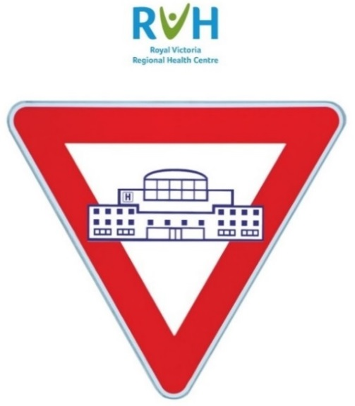

Where applicable, the Broset Violence Checklist Tool shall be used to evaluate the need for enhanced levels of observation. Please refer to Corporate Clinical Policy and Procedure, Enhanced Levels of Observation for Patients.

Where there is uncertainty regarding whether the person (patient) meets the above criteria, the patient’s primary care provider or Most Responsible Provider shall err on the side of caution and post the identifier. However, he/she/they shall contact Security Services for further guidance to ensure appropriateness and/or consistency.

This appendix provides an overview of Corporate Administrative Policy and Procedure, Workplace Violence Prevention. Please refer to the policy itself for definitions, responsibilities and other legislated requirements. If more information is required, contact Security Services at extension 44111 or Occupational Health and Safety (OHS) at extension 42350.
Workplace violence is reported to you
Is there an immediate risk of further violence?
VIOLENCE CONTROL MEASURES:
- Summon immediate assistance by the most appropriate means (e.g., push Connecting Care SMART Badge duress button, pull Staff Alert Pendant)
- Activate Code White via telephone (dial 55 at main site and Rotary or 911 at remaining off-site facilities) or Code White button
- Preserve the scene, if possible
- Provide first aid or medical aid as needed for those involved
- Security Services shall determine whether to involve Barrie City Police
- In the case of fatality, critical injury or injury disabling worker from normal duties or requiring medical aid, OHS (or their designate) shall notify the Ministry of Labour (1-877-202-0008) and a certified JHSC worker member (from the applicable union or worker group, if possible)
What type of violence is it?
External
Client/Customer
Worker to worker
Domestic violence
Submit a report of the incident, including information about those injured, witnesses, and identity of perpetrator(s) via the Safety Learning System.
YES
NO
Security Services shall investigate circumstances of the event
If client (patient) remains on site, case manage with appropriate interdisciplinary team members
Security Services shall investigate circumstances of the event
Security Services shall determine whether to involve Police
Security Services shall investigate circumstances of the event with the manager/ supervisor and/or HR designate
If workers remain on site, case manage with appropriate interdisciplinary team members
Contact Security Services
Security Services shall investigate, determine level of risk, discuss circumstances with the impacted worker’s leader (if required/appropriate)
Security Services implements trespass (as needed) and case manages with appropriate interdisciplinary team members
Leader to implement and document (on SLS Investigation page) short-term and long-term corrective actions, including any or all of the following (as applicable in the circumstances): creation of worker safety plans (with Security), adjustment to patient care plan, flagging of patient, Security VIP notation in Meditech, sharing of information at bullet rounds/shift changes, documentation in patient EMR and/or Kardex, etc.), debriefing to all involved, referral to EFAP and/or other community services, and updating of workplace violence risk assessment.
Contact Security Services
Attempt to re-direct or de-escalate. Contact Security Services if unsuccessful.
Depending on acuity, use self-resolution strategies
Security Services shall determine whether to involve Police
Security Services shall determine whether to involve Police
Security Services implements trespass or permanent ban (as needed)
Contact Security Services
Security Services shall determine whether to involve Police

