PURPOSE AND SCOPE:
To outline Markham Stouffville Hospital’s (MSH) expectations with regard to establishing and maintaining an early identification and communication system for patients at risk for violent behaviour. Alerting activities are not intended to stigmatize at-risk patients, and will be conducted in a manner that respects ethical principles and aligns with the organization’s honor to care.

To outline communication processes that will provide necessary information and preventive measures to staff regarding patients who present a history and/or risk of violent, aggressive or responsive behaviour in the workplace.

The scope of this document applies to all employees, professional staff, students, volunteers, contractors, and agents of MSH.

POLICY STATEMENT(S):
It is the policy of Markham Stouffville Hospital:
- That violence in the workplace is unacceptable. MSH is committed to providing a safe and respectful environment, and will implement measures and procedures to prevent, control and minimize the risk of violence.
- To support the use of routine preventative practices (see Appendix C) for all patients, and enhanced preventative practices for at-risk patients. Enhanced preventative practices shall be individualized and patient centered, based on any risks identified, while ensuring the protection of workers.
- That when a patient has been identified as a moderate or high risk, they and/or their substitute decision makers (SDMs) will be provided with information regarding the Alert for Behavioural Care (ABC), when safe to do so, and will be provided with contact information for further resources should they request it.
- Each inpatient will be assessed using a standardized and validated violence risk screening tool (see Appendix A). An individualized Alert for Behavioural Care plan will be developed for those patents assessed as being moderate or high risk for violence.

PROCEDURE:
At any time
Everyone within the scope of this policy | - For all patients;  - Use routine preventative practices (see Appendix C)  - For patients with purple armbands, signage on room door, or when visiting 1Wf;  - Speak with assigned nurse/delegate prior to approaching patient to verify Alert for Behavioural Care Plan.  - Continue with routine preventative practices and follow direction of nurse/delegate in approaching patient.  - Seek assistance from staff/security at any time as needed.  - Immediately alert security as needed when any patient is acting in a way that is threatening or potentially threatening to their safety, the safety of others, and/or hospital property; calling a Code White as needed.
Assessing for violence risk and initiating an Alert for Behavioural Care (ABC) in the Emergency Department (ED)
- Screening questions on a patient’s first presentation to MSH will consider:
  - Any known history of violence as reported by family/police/emergency services
  - Any previous permanent special indicator
  - Does the patient demonstrate any behaviour(s) suggesting increased risk of violence (refer to Violence screening tool for a list of example behaviours)
Triage Nurse | - For all patients;  - Complete screening questions on triage assessment.  - If any one of screening question is “Yes” alert primary nurse/FN in the ED to determine most appropriate care area and next steps.  - If all screening questions are “No” no further action is required.
Primary Nurse | - For all patients;  - If low risk has been identified at triage, no other further action is required unless patient, at any time, demonstrates behaviours suggesting an increased risk for violence, or a violent incident occurs.  - For patients for whom a screening question has been answered “yes” at triage or who demonstrates behaviours suggesting an increased risk for violence, or a violent incident occurs;  - Use routine preventative practices and consider strategies in Appendix D (Care Planning document) to manage patient.  - Complete a detailed Violence/Aggression Assessment Checklist (VAAC) screening.  - If the patient is screened to be moderate or high risk, develop and document an Alert for Behavioural Care (ABC) Safety plan to include risk behaviours, contributing factors, and patient specific de-escalation techniques.  - Discuss with patient/family members when appropriate, and apply poster on door as soon as possible, and purple armband when safe to do so.  - Notify facilitating nurse (FN), Charge Nurse or Clinical Leader (CL)/ Clinical Coordinator (CC) and interprofessional care team of Alert for Behavioural Care and ensure the information has been placed in the patient Kardex.  - Continue to assess and monitor patient’s status, and document observations or changes to care plan every 24hrs or as needed.  - Poster on door and purple armband will remain on patient during their hospital stay.  - Seek support as needed (e.g. security, colleagues, FN, CL, Charge Nurse, manager).  - Ensure Alert for Behavioural Care Plan is communicated to interprofessional team, and during care transitions.  - Notify Clinical Leader/ Charge Nurse or manager if patient meets criteria for permanent alert.
Facilitating Nurse,  Clinical Leader, Charge Nurse, Patient Care  Manager, or  Clinical Operations Manager |  | - For patients who are screened to be moderate or high risk;  - If armband and poster has not been applied, apply purple armband (when safe to do so) and poster to door. Ensure staff is aware of risk status and ABC plan.  - Provide the ABC pamphlet to the patient or SDM when safe to do so.  - Seek support as needed (e.g. security).  - If factors exist that prevent disclosure during the same shift (e.g., imminent safety concerns, or a patient’s inability to comprehend materials), document the decision in the patient’s chart and report it to the oncoming Facilitating Nurse/Clinical Leader/Charge Nurse/Patient Care Manager/Clinical Operations Manager.  - At discharge, with input from team, determine if patient meets criteria for a permanent alert that would be noted as a special indicator in the electronic health record.
Assessing for risk and initiating an ABC for all inpatients (see next section for Mental Health patients) on admission and after any violent incident)
Primary/ Assigned Nurse |  | - Complete a detailed Violence/Aggression Assessment Checklist (VAAC) screening tool (Sections A and B) on all patients on admission.  - For patients screened to be at low risk,  - Continue routine preventative practices.  - Continue regular care.  - For patients screened to be moderate or high risk  - Use routine preventative practices and consider strategies in Appendix D (Care Planning document) to manage patient.  - Develop and document an Alert for Behavioural Care (ABC) Safety plan to include risk behaviours, contributing factors, and patient specific de-escalation techniques.  - Discuss with patient/family members where appropriate and apply poster to door as soon as possible, and purple armband when safe to do so. Provide the ABC pamphlet to the patient or SDM when safe to do so.  - Notify facilitating nurse (FN), Clinical Leader (CL), Charge Nurse, Patient Care Manager (PCM), and/or Clinical Operations Manager (COM) of Alert for Behavioural Care.  - Ensure Alert for Behavioural Care Plan is communicated to interprofessional team, and during care transitions.  - Seek support as needed (e.g. security, colleagues, FN, CL, Charge Nurse, manager).  - Continue to assess and monitor patient’s status, and document observations or changes to care plan according to unit standards, and as needed.  - Notify Clinical Leader/Charge Nurse or manager if patient meets criteria for permanent alert.
Facilitating Nurse,  Clinical Leader, Charge Nurse, Patient Care  Manager, or  Clinical Operations Manager |  | - For patients who are screened to be moderate or high risk  - If armband and poster has not been applied, apply purple armband (when safe to do so) and poster to door. Ensure staff is aware of risk status and ABC plan.  - Provide the ABC pamphlet to the patient or SDM when safe to do so.  - Seek support as needed (e.g. security).  - If factors exist that prevent disclosure during the same shift (e.g., imminent safety concerns, or a patient’s inability to comprehend materials), document the decision in the patient’s chart and report it to the oncoming manager/clinical coordinator/clinical leads.  - At discharge, with input from team, determine if patient meets criteria for a permanent alert.
Assessing for risk and initiating an ABC for all Mental Health inpatients
In a mental health setting, clinicians assess the risk of harm to self or others on a regular basis. Screening and assessment tools such as the VAAC assist the clinician in identifying risk. These tools do not replace the clinical judgement of the clinician.

Consideration must be made that patients who are assessed to be moderate or high risk - based on current behaviours, assessment using the VAAC and clinical judgment - should not be given off ward privileges or must be accompanied by a clinical staff to any tests/appointments
Primary/ Assigned Nurse |  | - Complete a detailed Violence/Aggression Assessment Checklist (VAAC) screening tool (Sections A and B) on all patients every day.  - For patients screened to be at low risk,  - Continue routine preventative practices  - Continue regular care.  - For patients who are screened to be moderate or high risk  - Use routine preventative practices and consider strategies in Appendix D (Care Planning document) to manage patient.  - Develop and document an ABC Safety plan to include risk behaviours, contributing factors, and patient specific de-escalation techniques.  - Discuss with patient/family members where appropriate.  - Notify Clinical Leader (CL)/ Charge Nurse of Alert for Behavioural Care.  - Ensure Alert for Behavioural Care Plan is communicated to interprofessional team, and during care transitions.  - Seek support as needed (e.g. security, colleagues, Clinical Leader, Charge Nurse, manager).  - Continue to assess and monitor patient’s status, and document observations or changes to care plan as needed.  - Notify Clinical Leader/Charge Nurse or manager if patient meets criteria for permanent alert.
Facilitating Nurse,  Clinical Leader, Charge Nurse, Patient Care  Manager, or  Clinical Operations Manager |  | - Ensure signage is placed at the staff entrance that advises staff to speak with nurse before entering any patient room  - For patients who are screened to be moderate or high risk;  - Ensure staff is aware of risk status and ABC plan  - Seek support as needed (e.g. security).  - At discharge, with input from team, determine if patient meets criteria for a permanent alert.
Permanent ABCs
Applying a Permanent Alert for Behavioural Care Special Indicator
- A Permanent Alert for Behavioural Care (ABC) Special Indicator may be placed on a patient’s electronic health record when there is:
  - A consistent high risk score on the assessment tool during hospital stay
  - Any violent incident causing severe property/personal harm during hospital stay
  - Reported/confirmed history of significant violence in the community
  - Potential for violent behaviours associated with symptoms of chronic illness (e.g. dementia), mental illness, addiction, and/or developmental delay (e.g. autism)
At discharge and if at any time during the hospital stay when criteria are met to assign a ABC Special Indicator, the following process is followed;
Clinical Leader, Charge Nurse,  Patient Care Manager or Clinical Operations Managers |  | - With input from the interprofessional team, determine if the patient meets criteria for a permanent alert.  - If Interprofessional team agree that ABC be permanent,  - Arrange discussion of the need for a permanent ABC with the patient/SDM prior to discharge when possible and/or safe to do so.  - Provide rationale for decision.  - Inform patient/SDM of who to contact to appeal decision.  - Document the permanent alert (apply special indicator) in the patient’s electronic medical record.
Appeals, complaints management, reconsideration process
If a patient or their SDM wishes to appeal or challenge the ABC status the following process will be followed
Patient/ SDM |  | - Contact Patient Relations to appeal decision to add permanent alert (special indicator).  - Complete Appeals Request form (Appendix E) and submit to patient relations.  - Attend first half of appeals hearing.  - Contact Patient Relations if unhappy with decision of the Core Appeals Team.
Patient Relations |  | Upon inquiry by a patient/SDM regarding the appeals process:  - Inform patient/SDM of appeals process.  - Document discussion with patient/SDM in Patient Relations file.  - If patient/SDM chooses to appeal, notify Patient Relations Admin Clerk.  - Send patient the appeals request form for completion.  - Notify the manager of the area where the appeal of a permanent alert (special indicator) was requested.  - Notify the Core Appeals Team members of the request to appeal. Core appeals team members include:  - Patient Relations  - Unit specific Social Worker  - Ethicist  - Unit specific Clinical Director  - Patient Safety Leader  - OHS/HR Representative  - Third Party Physician  - Schedule a meeting within 30 days for an appeal hearing.  - File documentation of appeals decision in patient’s Patient Relations file.  - If patient requests to appeal decision made by Core Appeals Team, notify Senior Leadership Team and Risk.
Patient Care Manager /  Most Responsible Physician |  | - Attend first half of appeals hearing.  - Present objective data regarding rationale to assign a permanent alert.
Core Appeals Team Members |  | - Attend appeals hearing.  - Follow the IDEA Ethics Framework for Decision Making to determine if permanent alert will be removed.  - All Core Appeals Team members present at appeal must be in agreement with decision.  - If all team members are not in agreement, a second meeting of the Core Appeals Team members may be requested.  - If all team members are not in agreement, the Core Appeals Team will notify Risk and Senior Leadership for support and assistance.  - Document the discussion using the IDEA Ethics Framework.  - Draft a letter to the patient/SDM outlining the decision and reasons.  - Enter note in patient’s electronic medical record regarding appeal and decision.  - If decision to remove permanent alert is made, remove permanent alert from patient’s electronic medical record.  - Send all documentation to Patient Relations.
Senior Leadership Team/ Risk |  | - Review case.  - Follow the IDEA Ethics Framework for Decision Making to determine if permanent alert will be removed.  - Document the discussion using the IDEA Ethics Framework.  - Draft a letter to the patient/SDM outlining the decision.  - Enter note in patient’s electronic medical record regarding appeal and decision.  - If decision to remove permanent alert is made, remove permanent alert from patient’s electronic medical record.  - Send all documentation to Patient Relations.

DEFINITION(S):
Alert for Behavioural Care (ABC): A visual and / or electronic alert used to:
- inform staff of a risk of violent, aggressive or responsive behaviours
- signal additional and individualized care-needs and preventive measures
Alert for Behavioural Care Plan: A documented plan that details the care to be provided to prevent or control violent, aggressive or responsive behaviours. It is developed by a clinical healthcare worker or team in collaboration with (when possible) the patient and / or substitute decision-maker (SDM).
Alerting: A standardized method to communicate safety concerns to workers
At-risk patient: A patient who poses a risk for violent, aggressive or responsive behaviours. At-risk patients will be identified as moderate or high risk.
Appeals, Complaints management/ Requesting for reconsideration process: In the context of an ABC, the complaints management/ reconsideration process is the act of addressing a patient’s and/or SDMs concern with an alert decision. The process involves:
- Open communication and sharing of information
- Explanations of alert policies and procedures
- Decisions and rationales
- Patients will be advised of the appeals process
Enhanced preventative practices: These are heightened measures used to prevent violent, aggressive or responsive behaviours in at-risk patients and protect staff based on care needs and risk assessment.
Patient: For the purpose of this policy, a patient is any recipient of care.
Responsive Behaviours: A protective means by which persons with dementia or other conditions may communicate an unmet need (e.g., pain, cold, hunger, constipation, boredom) or reaction to their environment (e.g., lighting, noise, invasion of space).
Routine Preventative Practices: Violence-prevention strategies such as active listening, awareness of personal space and empathy that are used with all patients to prevent violent, aggressive or responsive behaviours (See Appendix C).
Special Indicator: An alert on the electronic medical record (Meditech) that is displayed on the patient’s electronic chart. Once applied, the special indicator will be displayed on every subsequent visit by the patient, unless removed.
Staff: Staff members can be: clinical healthcare workers, non-clinical healthcare workers, managers, administrative personnel, physicians, students, as well as any individual who has a working relationship with this MSH. In this policy, the terms ‘worker’ and ‘staff’ are used interchangeably, and extend to volunteers of the MSH.
Trigger: A circumstance or situation that may initiate, provoke or impact patient behaviour. Triggers may be physical, psychological or activity-related.
Violent behaviour: Acts of violence such as but not limited to choking, punching, hitting, shoving, pushing, biting, spitting, shouting, swearing, verbal threats, groping, pinching, kicking, throwing objects, shaking fists, and threatening assault.
Visitor: Any person who enters the workplace who is neither a patient nor a worker.
Workplace violence: Under the OHSA, workplace violence means:
- the exercise of physical force by a person against a worker, in a workplace, that causes or could cause physical injury to the worker;
- an attempt to exercise physical force against a worker, in a workplace, that could cause physical injury to the worker; or,
- a statement or behaviour that it is reasonable for a worker to interpret as a threat to exercise physical force against the worker, in a workplace, that could cause physical injury to the worker.

REFERENCE(S):
Not Applicable.

RELATED DOCUMENTS:
Privacy of Personal Health Information
Workplace Violence and Harassment Prevention
Code White – Violent Person
Personal Safety Devices (PSD)

RESPONSIBILITY:
Required Endorsements | Sponsor | Approval Authority
Clinical Operations Committees – All services  Senior Leadership  Interprofessional Advisory Committee  Patient Relations  Risk Management  Joint Occupational Health and Safety Committees | Professional Practice Leader | Director, Interprofessional Practice and Education

DOCUMENT HISTORY:
Type | Individual/Committee | Date | Outcome
Draft | Professional Practice Leader | 30/08/2018 | New Document; Approved
Revise | Professional Practice Leader; Joint Occupational Health and Safety Committees | 04/03/2021 | Minor Revision; Obtain JOHSC endorsement;

APPENDICES:
Appendix A: Violence/Aggression Assessment Checklist (VAAC)
Appendix B: Algorithm; Alert for Behavioural Care Process for Patients on Admission
Appendix C: Alert for Behavioural Care Routine Preventative Practices; SCAN
Appendix D: Care Planning Guide for Patients with Alert for Behavioural Care
Appendix E: Permanent Alert for Behavioural Care (ABC) Special Indicator Appeal Form

Appendix A: Violence/Aggression Assessment Checklist (VAAC)
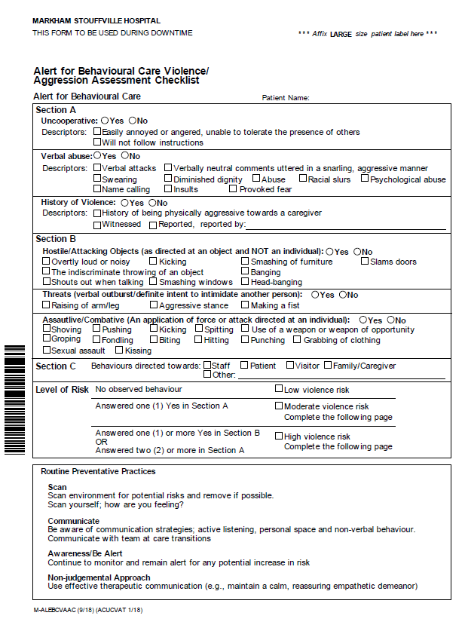

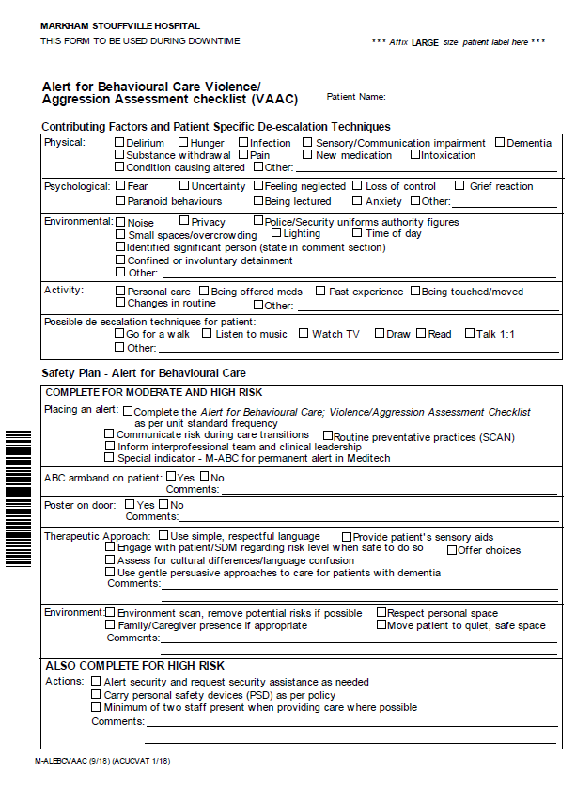

Appendix B: Alert for Behavioural Care Process for Patients on Admission

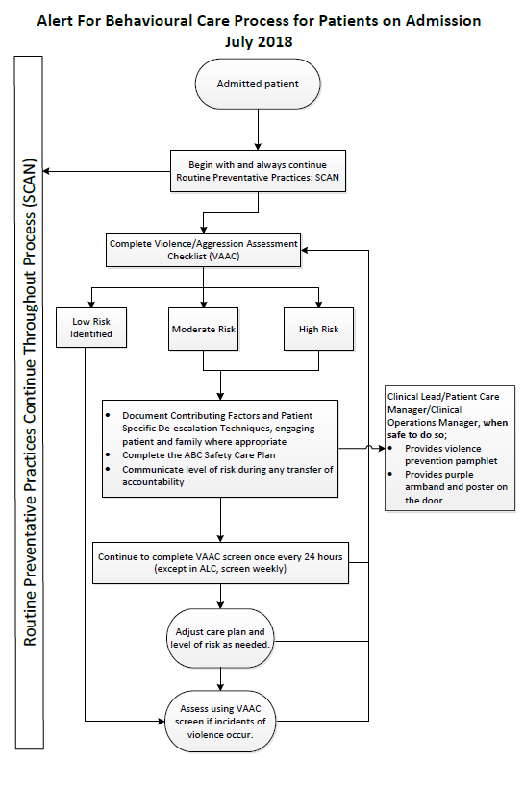

Appendix C: Alert for Behavioural Care Routine Preventative Practices; SCAN

Appendix D: Care Planning Guide for Patients with Alert for Behavioural Care

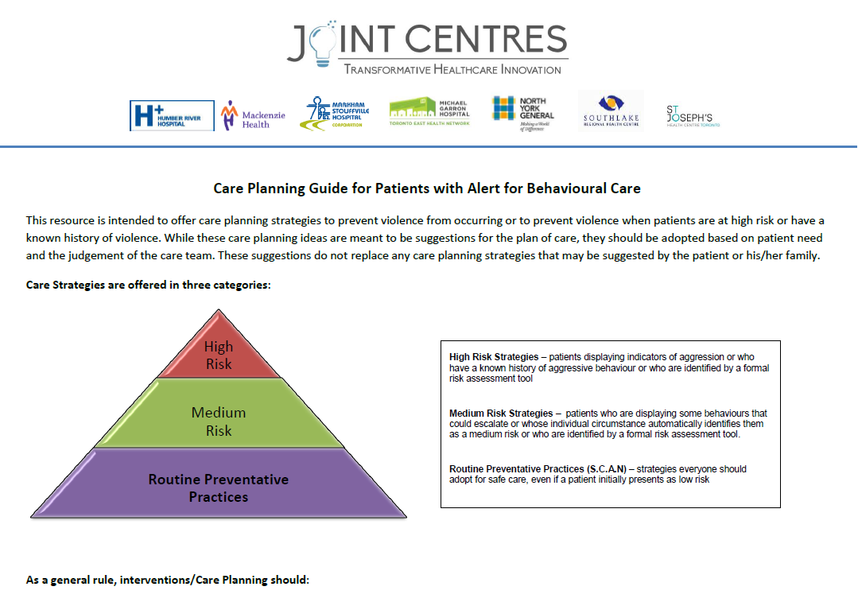
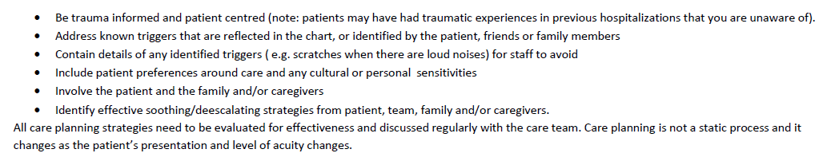
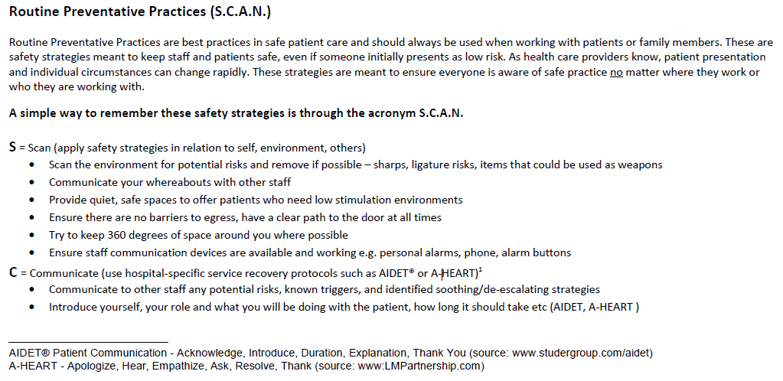
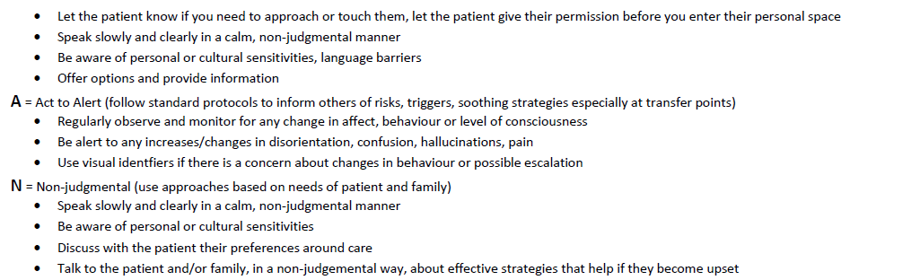

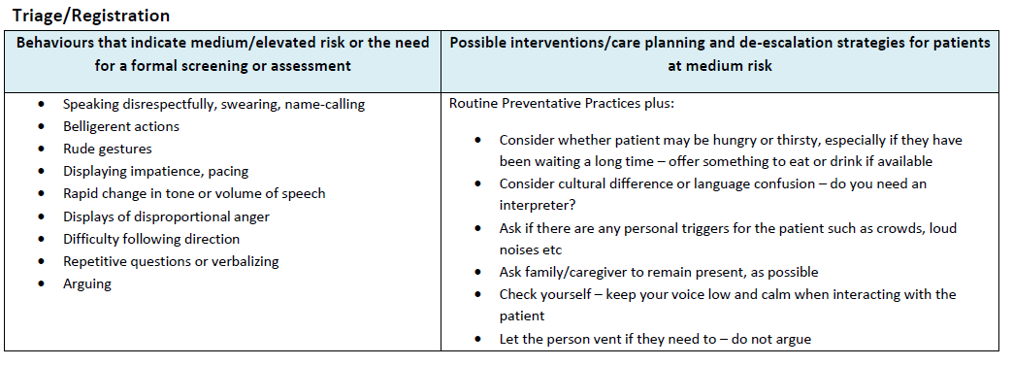
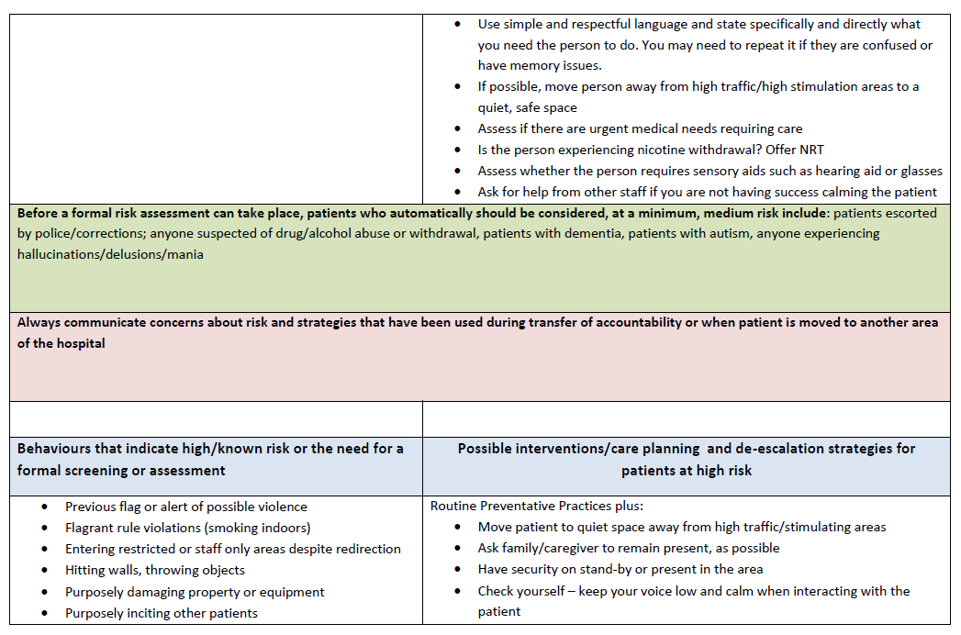
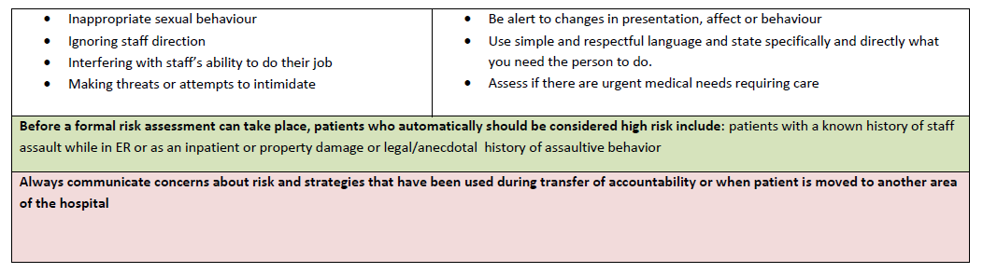
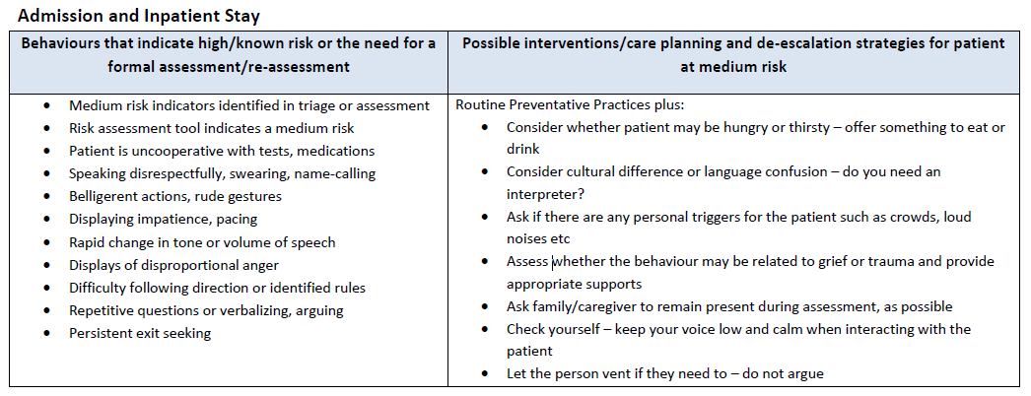
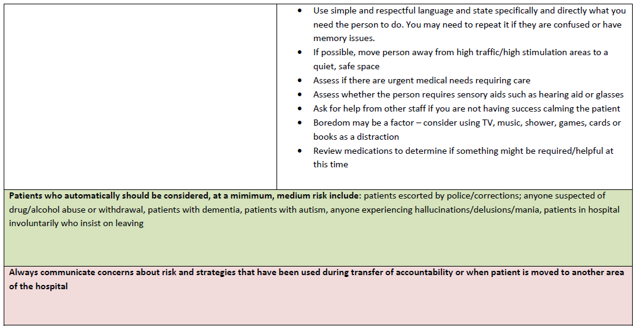

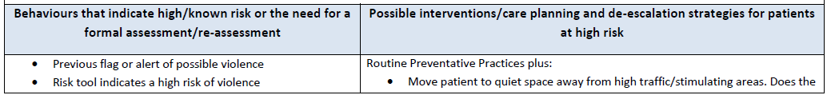
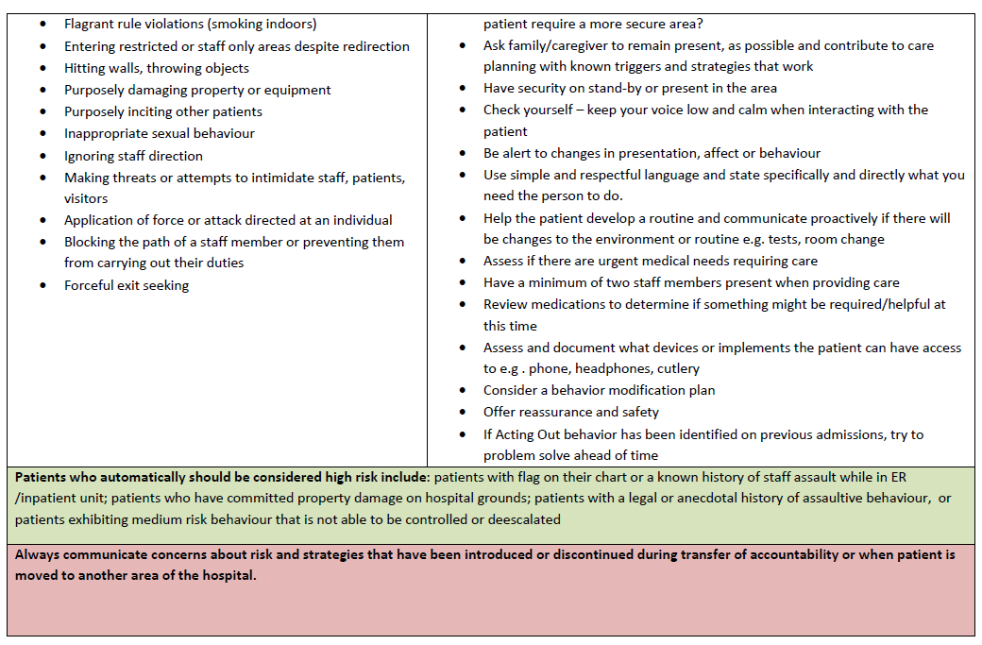

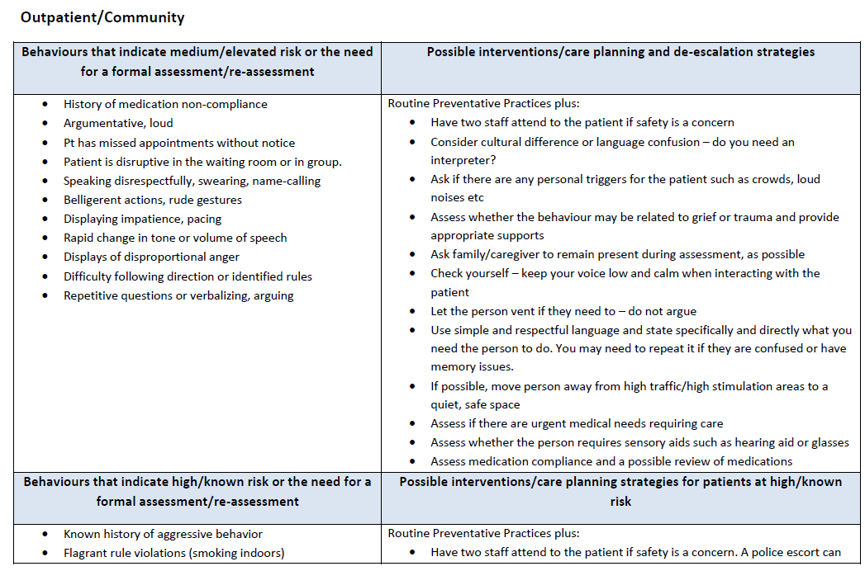
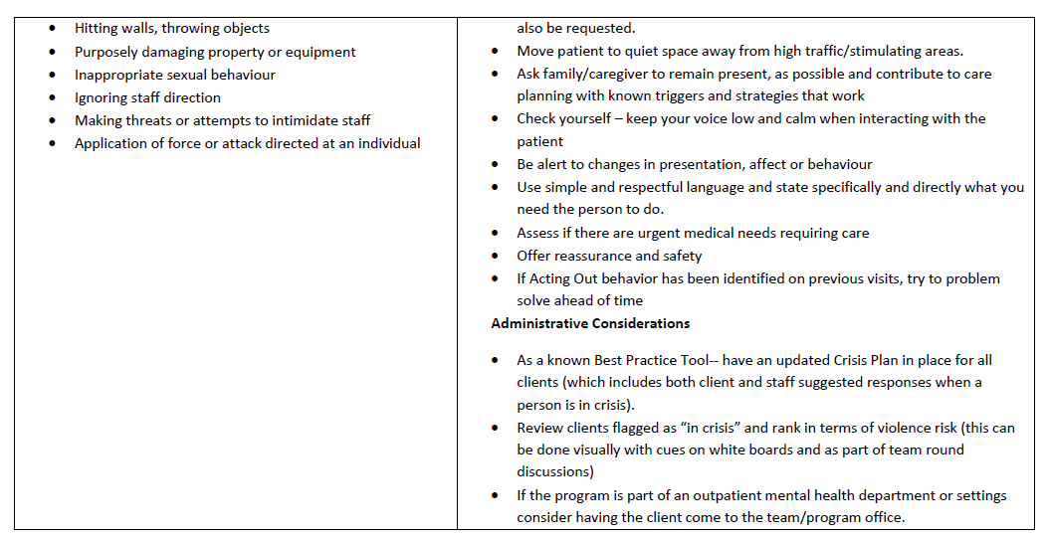
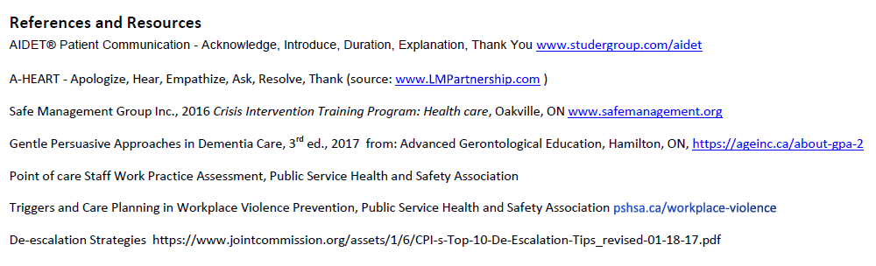

APPENDIX E: Permanent Alert for Behavioural Care (ABC) Special Indicator Appeal Form
