**Preventing Falls**

## How you and your family can help.

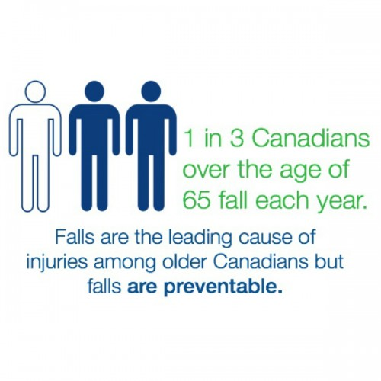

**WHAT CAN YOU DO TO PREVENT A FALL?**

**ASK FOR ASSISTANCE IF NEEDED**

* Inform nurse of previous falls/poor balance when walking
* Make sure you have your call bell within reach
* Be sure to wear well-fitted footwear with non-slip soles
* Do **NOT** use furniture to support yourself as it may be on wheels
* Please wear your hearing aid(s) and eyeglasses
* If you use a wheelchair or wheeled walker make sure the brakes are on before sitting or standing
* Keep your personal items close by
* Report to staff if you see a spill or obstacles on the floor
* Ask staff for assistance by using your call bell. **Please be patient and wait for help to arrive**
* Get up slowly. Sit on the edge of the bed before trying to stand up
* If its dark, have the lights turned on
* If you use a walking aid, make sure you use it always. **Ask for help if your walking aid is not within reach**
* Get your balance before starting to walk

**Falls are the leading cause of injuries among older Canadians but falls are preventable.**

## WHY ARE YOU AT RISK FOR FALLING?

* Past history of a fall
* Poor balance when walking
* Recent illness or surgery
* Unfamiliar environment/ equipment
* Slippery or poorly fitting footwear
* Urgent need to go to bathroom
* Confusion
* Taking multiple medications or medications with side effects.



## WHAT CAN HAPPEN WHEN YOU FALL WHILE IN HOSPITAL

* Longer hospital stay
* Hip fracture
* Blood clots
* Need for rehabilitation
* Loss of independence

