PROCESS INTERVENTION SCREEN

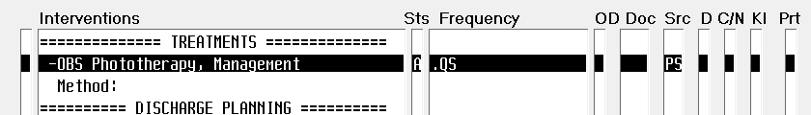

CDS INTERVENTION SCREEN

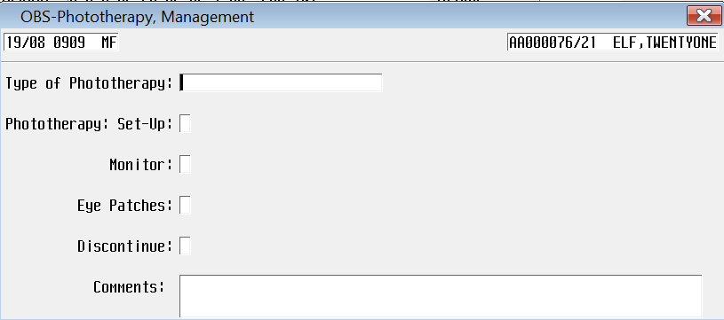

                Type of phototherapy - look up screenshot

