# Orientation Schedule



**September 2021 (Maps Attached)**

|  |  |  |  |
| --- | --- | --- | --- |
| **\*\*Please report to the South Muskoka Memorial Hospital Conference Room (All Staff)**  **0830-1630 September 8, 2021** | | | |
|  | | | |
| **Time** | **Topic** | | **Presenter** |
| **0830-0840 (10 min)** | **Welcome & Introductions** | | **Human Resources** |
| **0840-0905 (25 min)** | **Organizational Overview: Vision, Mission, Values** | | **Senior Leadership** |
| **0905-0930 (25 min)** | **Communication** | | **Allyson Snelling** |
| **0930-1030 (60 min)** | **Infection Control** | * **IPAC Policies & Procedures** * **Screening** * **Isolation** | **IPAC** |
| **1030-1045** | **Break** | | |
| **1045-1200 (75 min)** | **Codes: Red (Fire Extinguisher Training Video included), Green, Orange** | | **Christine Maurer** |
| **1200-1230 (30 min)** | **Lunch** | |
| **1230-1415 (105 min)** | **Codes:  Brown, White, Yellow, Purple, Silver** | |
| **Codes:  Black, Blue, Pink, Rapid Response** | |
| **1415-1445 (30 min)** | **Confidentiality & Privacy** | | **Frankie Dewsbury** |
| **1445-1500** | **Break** | | |
| **1500- 1615 (75 min)** | **Health & Safety**  **Lifts  & Transfers** | | **Occupational Health** |
| **1615-1630 (15 min)** | **Employee Services / HR**  **Wrap-Up & Evaluations** | | **Human Resources** |
| **End of Day** | **Mask Fit Testing**  **Union Meet & Greet** | | **Occupational Health Union Representatives** |

|  |  |  |
| --- | --- | --- |
| **\*\*Please report to the South Muskoka Memorial Hospital Conference Room** **(All Staff)**  **0800-1300** **September 9, 2021** | | |
| **Time** | **Topic** | **Presenter** |
| **0800-0830 (30 min)** | **HIS Computer Introduction** | **Leslie Secord / James Jones** |
| **0830-0845 (15 min)** | **LMS** | **Christine Maurer** |
| **0845-0900 (15 min)** | **Huntsville District Memorial Hospital & South Muskoka Hospital Foundations** | **Natasha Nieder / Leah Walker** |
| **0900-11:00 (120 min)** | **Service Excellence** | **Robert Alldred-Hughes** |
| **Break** |
| **Patient Safety** |
| **1100-1115 (15 min)** | **Patient & Family Centered Care** | **Kristin Cazabon/Laura Derbyshire** |
| **1115-1130 (15 min)** | **Ethics** | **Kristin Cazabon/Laura Derbyshire** |
| **1130-1200 (30 min)** | **Fall Risk, Fall Prevention** | **Kristin Cazabon/Laura Derbyshire** |





|  |  |  |
| --- | --- | --- |
| **\*Please report to the South Muskoka Memorial Hospital Conference Room** **(All Staff)**  **0800-1600** **September 10, 2021** | | |
| **0800-0945** | **The Mandt System** | **Christine Maurer** |
| **0945-1000** | **Break** |
| **1000 - 1200** | **The Mandt System** |
| **1200 – 1230 (30 minutes)** | **Lunch** |
| **1230-1430** | **The Mandt System** |
| **1430 – 1445** | **Break** |
| **1445-1600** | **The Mandt System** |

|  |  |  |
| --- | --- | --- |
| **\*Please report to HDMH Building B** **(RNs, RPNs, AHPs, NPs, Ward Clerks)**  **0800 -1600** **September 13, 2021 **Exclude Lab Technologists & Lab Technicians** | | |
| **Time** | **Topic** | **Presenter** |
| **0800-0815 (15 min)** | **Cerner Log-in (ensure everyone’s access)** | **Monique Charlton & Cerner Trainer / Facilitator** |
| **0815-1015 (120min)** | **PowerChart** | **Cerner Trainer / Facilitator** |
| **1015-1030 (15 min)** | **Break** |
| **1030-1130 (60 min)** | **PowerChart** |
| **1130-1200 (30 min)** | **PowerChart Test** |
| **1200-1230 (30 min)** | **Lunch** |
| **1230-1400 (90 min)** | **PowerOrders** |
| **1400-1415 (15 min)** | **Break** |
| **1415-1515 (60 min)** | **PowerOrders** |
| **1515-1545** | **PowerOrders Testing** |
| **1545-1600** | **Downtime Procedures** |
| **1600** | **Wrap-up** |

|  |  |  |
| --- | --- | --- |
| **\*Please report to HDMH Building B** **(RNs, RPNs, NPs, Ward Clerks)**  **0800 -1600** **September 14, 2021** | | |
| **Time** | **Topic** | **Presenter** |
| **0800-0900 (60 min)** | **Medications – Review of Nursing Accountabilities (CNO)** | **Cerner Trainer / Facilitator** |
| **0900-1000 (60 min)** | **eMAR training, inclusive of intake and output** |
| **1000-1015 (15 min)** | **Break** |
| **1015-1115 (60 min)** | **eMAR training, inclusive of intake and output** |
| **1115-11455 (30 min)** | **eMAR Testing** |
| **1145-1215** | **Lunch** |
| **1215-1400 (105 min)** | **CareNet / HOBIC** |
| **1400-1415 (15 min)** | **Break** |
| **1415-1530** | **CareNet** |
| **1530-1600** | **CareNet Testing** |
| **1600** | **Wrap-up** |





|  |  |  |
| --- | --- | --- |
| **\*Please report to South Muskoka Memorial Hospital Conference Room (RNs, RPNs, NPs) 0800-1600** **September 15, 2021** | | |
| **Time** | **Topic** | **Presenter** |
| **0800-0810 (10 min)** | **Welcome and Introductions** | **Clinical Educator** |
| **0810-0830 (20 min)** | **Model of Care**   * **SharePoint: Clinical Education department site** * **Nursing Unit Resources** * **MedWorxx learning Management System** (LMS) |
| **0830-0900 (30 min)** | **Professional Practice**   * **Skills Orientation Documents: RN, RPN** * **Discuss annual equipment reviews**: Hospira Infusion Pump, Kangaroo e-pump, VAC Therapy (VAC Ulta, InfoVAC, ActiVAC, VAC Via), Nova Stat Strip * **Suggested content for annual professional self-reviews** * **ISMP:** dangerous abbreviations, symbols, dose designations (“Do Not Use List”) * **Ottawa Parenteral Drug Therapy manual:** must use for parenteral med. prep.   **-** used in association with MAHC IV drug list, hospital staff who may administer |
| **0900-0930 (30 min)** | **Patient Identification Process** |
| **0930-0945 (15 min)** | **Rapid Response Team Role** |
| **0945- 1000(15 min)** | **Break** |
| **1000-1045 (45 min)** | **Assessment Overview**   * **Common diagnoses** * **Routine and Diagnoses Focused** * **Vital Signs** * **Skin Assessment** * **Pain Assessment** |
| **1045-1230 (75 min)** | **“ABCD”**  **Airway & Breathing**   * **Oxygen therapy & airway management** (oral airway, BVM) * **Chest Tube Management** * **Thoracentesis**   “hands-on” practice |
| **1230-1300 (30 min)** | **Lunch** |
| **1300- 1330** | **Cardiovascular**   * **Chest Pain, CHF, Code Blue/ Code Pink** * **LMS registration for MAHC BLS Courses** |
| **1330- 1550** | **Circulation**  **Vascular Access Devices**   * **PIV, CVAD: Theory Review and CVAD occlusion management,** including indications & process for CathFlo * **Complete Infusion Pump Checklist** * **Pharmacy site:** approved IV drug list, Ottawa manual, IV direct vs IV push   “hands-on” practice  *break included during practice time |
| **1550-1600** | **Process to complete annual on-line modules:**   * **Transfusions: “Bloody Easy” on-line Module** * **Trillium Gift Of Life** * **Nova Stat Strip**   *completed certificates to be submitted to Chris Maurer |





|  |  |  |
| --- | --- | --- |
| **\*Please report to South Muskoka Memorial Hospital Conference Room (RNs, RPNs) 0800-1600** **September 16, 2021** | | |
| **Time** | **Topic** | **Presenter** |
| **0800-0805** | **Welcome** | **Clinical Educator** |
| **0805-0930 (85 min)** | **Disability**   * **Stroke Awareness**   o **Dysphagia Screening Tool**  *above presented by Donna Crump   * **seizure** * **neuro- head injury** |
| **0930-0945 (15 min)** | **Break** |
| **0945- 1015** | **TGLN** |
| **1015- 1230** | **Pressure Related Wound Management**   * **Documents: Braden Score** * **Products: Indications, Applications, Removal** * **Product autosub List** * **VAC Therapy; complete VAC Therapy checklist**   “hands-on” practice |
| **1230- 1300** | **Lunch** |
| **1300- 1400** | **Diabetes**   * **Review DEC** * **Capillary Blood Glucose Monitoring; complete NovaStat Strip checklist**   “hands-on” practice |
| **1400- 1430 (30 min)** | **Surgical**   * **Post-Op Routine** * **Dressings, Drains, Tubes** |
| **1430-1545 (75min)** | **Renal- Gastrointestinal- Renal**   * **Common lab** * **CBI, true urine** * **Ostomy** * **Enteral Feeds: NG insertion, complete Kangaroo e- Pump Checklist** * **FlexiSeal Bowel Management System**   “hands-on” practice  *break included during practice time |
| **1545-1600 (15 min)** | **Questions, Evaluation & Wrap-up** |

**Muskoka Algonquin Healthcare**



South Muskoka Memorial Hospital Site, Conference Room & Clinical Nurse Educator Training Room Locations

**Meeting Site:** Bracebridge, **South Muskoka Memorial Hospital**, 75 Ann Street. The Conference Room is located on the main floor in the hallway beside the elevators. Clinical Nurse Educator Training Room located on the second floor. Turn right when leaving the elevator, turn right at the next hallway, and at the end of this hallway the training room is on the left (Room 251) just before the stairwell.

**Driving Instructions:** Take the Taylor Road entrance in to Bracebridge and follow it to Hiram Street. Turn right on to Hiram Street (before Manitoba Street). Follow Hiram Street to the stop sign at Ann Street. Turn right on Ann Street, and the hospital is first left.

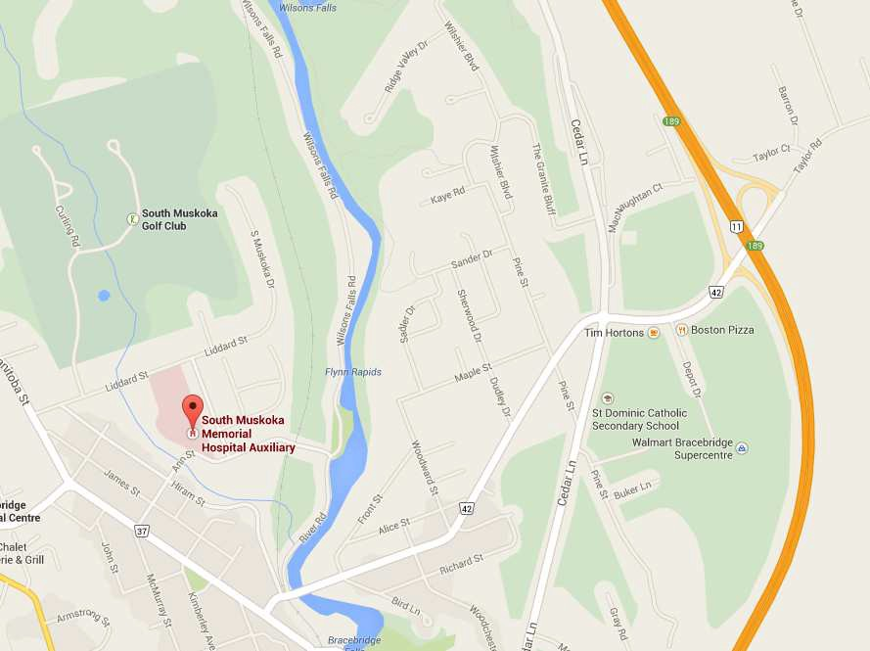**Parking:** Staff parking is behind the hospital on the left after you turn in from Ann Street. Your employee badge provides access into and/or out of the hospital and the staff parking lots.

**Muskoka Algonquin Healthcare** Huntsville District Memorial Hospital Site Building B



**Meeting Site:** Huntsville, 100 Frank Miller Drive, Building B, Conference Room. Door will be unlocked by 0800 hours.

**Driving Instructions:** Hwy 11 North or South to Huntsville, exit on to Hwy 60 (East), left (North) on to Muskoka Road 3, then left (West) on to Frank Miller Drive. As you go up Frank Miller Drive with the Hospital ahead of you, take the 1st driveway to the left, which will take you to a parking gate. Using your ID Badge, swipe through the parking gate and follow the driveway to the staff parking lots. Walk through the hospital or around the hospital outside, to Building B. Building B (includes Finance and NOSM) is the brick building at the far end of the parking lot of the Howland Building location (includes Diabetes Education Centre and One Kids Place).

**Parking:** Parking is available in the main Hospital parking lot or the staff parking lots at the back of the hospital. **Please do not park in the lot where the Building B Conference Room is located.**

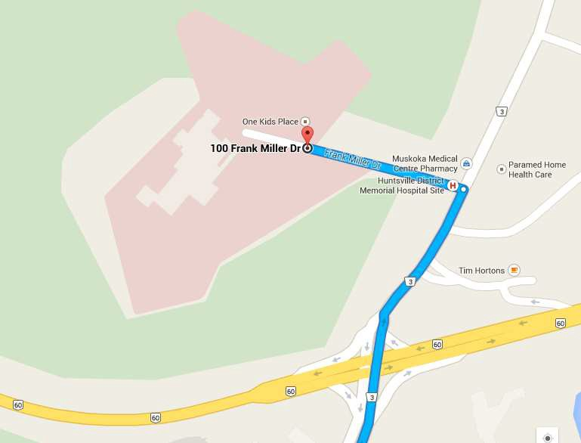

**Office Equipment Available:** Office includes electric kettle, fridge, micro wave, toaster oven. Please bring your own mug and cutlery. Sink available for dishes.

Feel free to bring your own lunch. Alternatively there are vending machine available in the Garden Court.