

**HURON PERTH HEALTHCARE ALLIANCE**

**MEDICAL DIRECTIVE**

|  |  |
| --- | --- |
| Medical Directive | X-Rays – Ankle, Wrist, Knee |
| Directive # | MD-ED-026 |
| Approval | Medical Advisory Committee |
| Date | May 2, 2024 |
| Signature |  |
| Review/Revision Date | Original – Dec/06, R – Apr/17, R – Feb/2021 |
| Specific to | HPHA Emergency Departments |

**Description of Procedure:**

* According to patient assessment criteria (see Appendix A) order the appropriate X-ray.
* Patient to remain NPO
* Apply ice pack to injuries less than 8 hours old but do not apply ice to obvious fractures/dislocations with tented skin.
* Splint obvious fractures to assist with pain control PRN
* Obtain urine for HCG testing and send to lab *if any risk of pregnancy.* 
  + If suspicion of pregnancy, while waiting for urine pregnancy test, consult with Physician before continuing with Medical Directive

**Authorized To:**

* Nurses who have completed the educational component specific to this medical directive in the eTRAIN module: ED Medical Directives are eligible to implement the directive

**Specific Patient Conditions:**

**Knee Injuries**

* Patients 12 years of age and older presenting with a knee pain suggestive of a fracture and a history of trauma or significant injury with positive OKR (Ottawa Knee Rules), enter a knee X-ray.

**Ankle/foot Injuries**

* Patients 12 years of age and older presenting with an ankle and/or foot pain suggestive of a fracture and a history of trauma or significant injury with positive OAR (Ottawa Ankle Rules) enter an ankle and/or foot X-ray.
  + For pain at the base of the 5th metatarsal, **and** navicular and patient meets ankle rules, only an ankle x-ray is required. Note: At the HPHA, imaging of the base of the 5th metatarsal is included in an ankle X-ray.
  + For pain only at the base of the 5th metatarsal and/or navicular (mid foot) area, only a foot x-ray is required.

**Wrist Injuries:**

* Patients 12 years of age and older presenting with wrist pain suggestive of a fracture and a history of trauma or significant injury enter a wrist X-ray.
* Also, enter an order for scaphoid X-ray when the patient 12 years of age and older has snuffbox tenderness (see Appendix A).

**Contraindications:**

* Lack of consent
* For all confirmed or suspected pregnant individuals, *notify the Physician for guidance regarding imaging*
* Patients with multiple painful injuries (i.e. multiple trauma patients)
* Patients with head injuries, neurological deficits or altered by drugs/alcohol

**Reasons to seek immediate medical consultation or discontinue procedure/ treatment/intervention:**

* Any neurovascular compromise
* Any deterioration in patient’s condition
* CTAS 1 & 2 patients
* Uncertainty as to whether or not the diagnostic imaging study should be initiated

**Documentation:**

* Implementation of the Medical Directive including name and number of the directive, name, signature and credentials of the implementer and name of the attending physician in the order section of the ED chart.

**Quality Assurance**

* The Medical Program Director, Emergency Medicine will approve the education component of the Medical Directive
* Nurses will complete the educational component specific to this medical directive on a biennial basis or as directed by their Unit Manager.
* A biennial review will be conducted at the discretion of the HPHA Emergency Medicine Program Council to review the appropriateness of the Medical Directive

|  |  |
| --- | --- |
| Originator | HPHA Emergency Department Team Leaders |
| Current Review/Revision | May 2024 |
| Responsibility | HPHA Emergency Medicine Program Council |
| Distribution | HPHA Emergency Department Manuals  MyAlliance, Medical Directives  StartHub, Medical Directives |

**Reference(s):**

* The Ottawa Rules. (n.d). The Ottawa Knee Rule. Retrieved from <http://www.theottawarules.ca/knee_rules>
* The Ottawa Rules. (n.d). The Ottawa Ankle Rule. Retrieved from <http://www.theottawarules.ca/knee_rules>

**Appendix A-Ottawa Rules & Assessment of Wrist Injuries**

Ottawa Ankle Rules (OAR) Criteria:

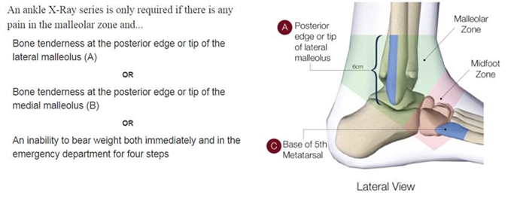

Please note:

* For pain at the base of the 5th metatarsal, **and** navicular and patient meets ankle rules, only an ankle x-ray is required. Note: At the HPHA, imaging of the base of the 5th metatarsal is included in an ankle x-ray.
* For pain only at the base of the 5th metatarsal and/or navicular (mid foot) area, only a foot x-ray is required.

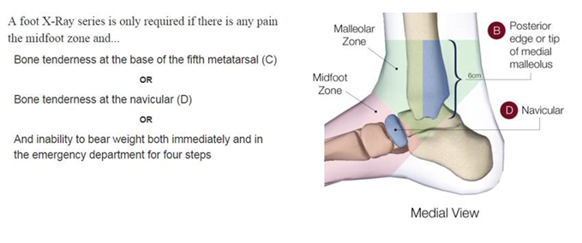

Ottawa Knee Rules (OKR) Assessment:

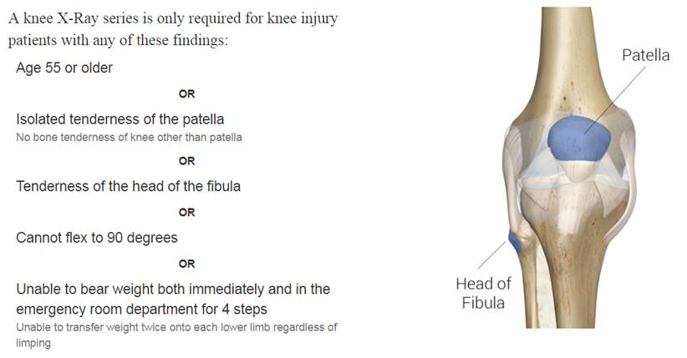

**Criteria for Wrist & Scaphoid XRAY**

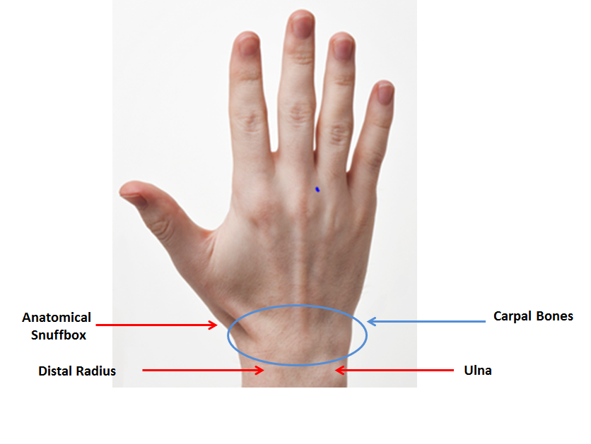

If pain identified in these areas on light palpation, enter a Meditech order for a Wrist XRAY.

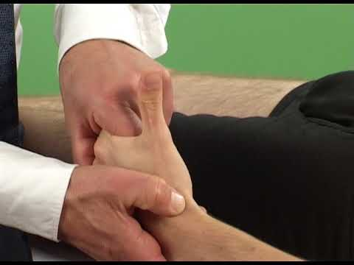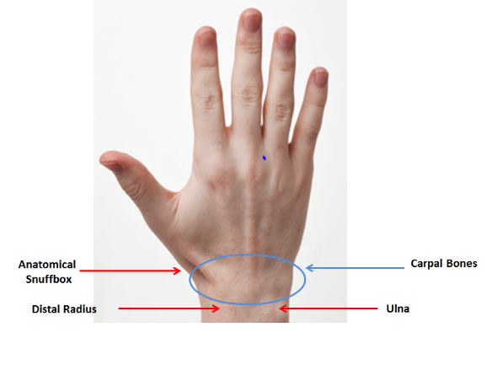

Also requires Scaphoid view XRAY if there is pain or tenderness on gentle palpation of snuffbox.